Thesis

Submitted in partial fulfilment of the requirements for the degree

**Master of Science**

“Sex Differences in Acute Visuospatial Neglect – An Exploratory Study Investigating Differences in Lesion Patterns and Disconnectome”

**Graduate School of Neural and Behavioural Sciences**

Faculty of Science  
Faculty of Medicine

Eberhard-Karls-Universität Tübingen

Presented by

Tamara Keßler,

born in Wiesbaden, Germany

Tübingen, [DATE OF SUBMISSION]

**Thesis Advisor:** Prof. Dr. Dr. Hans-Otto Karnath

Division of Neuropsychology   
 University Clinics Tübingen & Hertie Institute for Clinical Brain Research

**Second Reader:** Prof. Dr. Birgit Derntl

Department of Innovative Neuroimaging   
Centre for Mental Health Tübingen

**Disclosures:**

I affirm that I have written the dissertation myself and have not used any sources and aids other than those indicated.

I affirm that I have not included data generated in one of my laboratory rotations and already presented in the respective laboratory report.

Date / Signature: _

Table of Contents

Inhalt

1. Introduction: Sex Differences in Neuropsychology 6

1.1. Sex Differences in the Healthy Brain and General Cognition 6

1.2. Sex Differences in Stroke 9

1.3. Visuospatial Neglect 13

2. Material & Methods 16

2.1. Patient Sample 16

2.2. Behavioural Data 17

2.3. Neuroimaging Data 18

3. Data Analysis 20

3.1. Lesion Analysis 20

3.2. Whole-brain disconnectivity mapping 20

3.3. Region-to-Region Disconnectivity 21

3.4. Shortest Structural Path Lengths (SSPLs) 21

3.5. Prediction of Patient Status 22

4. Results 23

4.1. Clinical and Demographic Data 23

4.2. Voxel-based Lesion-Behaviour Mapping / Lesion Analysis 23

4.3. Whole-brain disconnectivity mapping 26

5. Discussion 28

6. Conclusion 29

References 30

Acknowledgements 36

Data Usage Statement 37

Appendix 38

Appendix A: List of Abbreviations 38

Appendix B: Supplementary Tables and Figures 39

Abstract

[200 words]

Cognition and brain health are influenced by many variables, one of them being biological sex.

## Introduction: Sex Differences in Neuropsychology

### Sex Differences in the Healthy Brain and General Cognition

Sex differences in cognitive abilities have been a widely discussed subject of interest since the 1870s already (for a review see Shields, 1975). Back then, research mainly relied on measures of head and brain size in an attempt to explain differences in cognitive capacities. Researchers such as Alexander Bain (1875) and George Romanes (1887), amongst others, reported that women had smaller overall brain volumes, which they proposed to be directly responsible for their inferior intellect and increased emotionality (Fee, 1979; Shields, 1975). Shields (1975) describes that many researchers at that time lacked the necessary impartiality to investigate the topic of sex differences, as they aimed “to discover the particular physiological determinants of female inadequacy” (p. 740).

Over the next few decades with the introduction of more precise and objective cognitive measurements, the prevalent opinions on sex differences in psychology changed. While some reviews at the time found no noteworthy differences in mental abilities between men and women (Hollingworth, 1918; Woolley, 1914), various studies reported superior performance in spatial and analytical tests for men, and higher verbal scores for women (for a review see Sherman, 1967). Theories of intellectual abilities, as measured by IQ, being linked to genetics were still prominent, even though not uncontroversial (Wittig, 1976). Some researchers even already pointed out that these described differences were inherently related to the stereotypical gender roles (Broverman et al., 1972; Sherman, 1967; Woolley, 1914).

Even so, the view that men and women are fundamentally different in certain cognitive domains remained relatively common throughout both the minds of the vast population, as well as the scientific community. This theory, which is commonly referred to as the “gender differences hypothesis”. While not a scientific work, Hyde (2005) argues that, even though it was not a scientific book, John Gray’s (1992) best-selling book “Men Are from Mars, Women Are from Venus” largely popularised this theory. [transition]

Nosek et al. (2009) found that about 70% of people from different nationalities hold implicit stereotypes of associating mathematics and science more strongly with men than with women.

Contrary to popular conceptions of sex differences, meta-analyses and meta-syntheses demonstrated that if any gender differences were detectable in cognitive tests, they often were negligibly small (Hirnstein et al., 2019; Hyde, 2005; Zell et al., 2015). Hyde (2005 & 2014) found that in most cognitive tasks, women and men achieved equal performances. The strongest and most robust difference in cognitive tasks that Zell et al.’s (2015) meta-synthesis identified was mental rotation. Voyer et al.’s (2016) meta-analysis identified a significant, albeit small male advantage in visuospatial working memory tasks. Thus, the “gender similarities hypothesis” was coined, stating that men and women are similar in most, but not all, psychological domains and that most existing differences tend to be small in magnitude (Hyde, 2005).

With the advent of neuroimaging, new possibilities emerged for more detailed and objective research of sex differences in the cognitive neurosciences. Nevertheless, there still is no consensus on the exact neural mechanisms underlying those cognitive sex differences.

Several structural magnetic resonance imaging (MRI) studies found that the volume of the crania and brain lobes are generally larger for men than for women – with those differences being more pronounced in white matter (WM) than for grey matter (Allen et al., 2003; Goldstein et al., 2001). These findings were interpreted as women having less WM than their male counterparts, rather than women having more grey matter. [However, the reported grey/white matter ratios vary across lobes and hemispheres.] (DETAILS) Interestingly, the corpus callosum was found to be less sexually dimorphic than white matter overall, which could be an indicator that white matter tracts are less sexually dimorphic than other white matter components, such as glial cells and blood vessels (Allen et al., 2003).

[more examples of differences]

* Numerous studies have reported that certain brain structures differ in (relative) size or shape differ between the sexes. Some examples include larger volumes in the amygdala, putamen and globus pallidus in males, and larger volumes in the hippocampus and caudate in females (Cosgrove et al., 2007; Giedd et al., 1996a & 1996b). Further, multiple studies have found that the corpora callosa of men and women differ in shape, especially in the splenium: Women have more bulbous splenia, whereas it is more tubular-shaped in men (Allen et al., 1991; more). However, such findings are not uncontroversial, as sex differences in the volume of brain structures may disappear when correcting for total brain or intracranial volume (Choleris et al., 2018; Eliot et al., 2021; Tan et al., 2016).
* Ingalhalikar et al., 2013:
  + Sex differences in the relative size and shape of specific brain structures have also been reported (Cosgrove et al., 2007), including the hippocampus, amygdala (Giedd et al., 1996 & 1997), and corpus callosum (CC) (Allen et al., 1991).
* Choleris et al, 2018:
  + Although a meta-analysis suggests that men have larger hippocampal volumes than women, this advantage disappears when hippocampal volume is adjusted for total brain or intracranial volume (Tan et al., 2016).

Studies employing diffusion tensor imaging (DTI) to investigate the architecture of WM and its fibre tracts found that over all age ranges, men tend to have increased measures of fractional anisotropy (FA) and decreased mean diffusivity (MD) than women. Higher measures of FA are thought to reflect increased axonal diameter, fibre bundle density and myelination, while the inverse relation holds for MD (Boespflug et al., 2011; Zasler & Kaplan, 2017). However, in a similar vein to Allen et al.’s (2003) findings of women having larger corpora callosa in proportion to the rest of their WM, Kanaan et al. (2012) were able to show that the corpus callosum in women has higher FA than in men. This could be interpreted as women’s corpora callosa exhibiting greater efficiency.

[describe Hemispheric asymmetry]

* Hausmann (2017)
  + Functional cerebral asymmetries (FCAs) refer to the relative differences between the left and the right hemispheres in some neural functions and cognitive processes and represent a relatively simple model for investigatingfunctional connectivity in the brain. Although FCAs are a fundamental principle of brain organization (e.g., the vast majority of human individuals are left lateralized for language), about half of the variation in FCAs is attributable to individual differences (Kim et al., 1990). This variation was simply treated as random error, and was usually ignored in the past (Hellige, 1993).
  + In healthy adults, sex differences in FCAs have been reported for many cognitive domains, including language, spatial orientation, spatial attention, and face recognition. Although contrary findings, most studies reporting sex differences have revealed reduced FCAs in females compared with males. Moreover, there is some evidence that women exhibit a greater degree of interindividual variability in FCAs, whereas FCAs in males are rather robust.
  + Merrill Hiscock and colleagues found stronger hemispheric asymmetry in males across a range of auditory (Hiscock et al., 1994), visual (Hiscock et al., 1995), tactile (Hiscock et al., 1999), and dual task interference (Hiscock et al., 2001) laterality tasks and concluded that, on the population level, sex differences in FCAs (i.e., larger FCAs in men than in women) are small but reliable (Hiscock et al., 2001). Daniel Voyer (1996, 2011) came to the same conclusion in his meta analyses. Small effect sizes imply that only studies using a large sample will reliably find sex differences in FCAs.
  + Hirnstein et al. (2013) compiled behavioral data from 1,782 participants (885 females) and found that sex differences in the degree of language lateralization, as measured with a well-established verbal dichotic listening task (Hugdahl, 1995), were dependent on age, with the largest effect (Cohen’s d= 0.31) in adolescents. […] The sex difference in this task observed by Hirnstein et al. (2013) is in line with a recent study by Bless et al. (2015) that assessed language lateralization in over 4,000 participants with a smartphone application (iDichotic). This study also revealed greater language lateralization in men than in women, with a small effect of Cohen’s d = 0.18. Although effect sizes in sex differences of language lateralization are small, they are consistent with, for example, recent anatomical findings showing greater leftward asymmetry of the planum temporale (which overlaps with Wernicke’s area) in men than in women (e.g., Guadelupe et al., 2015), which is established very early in ontogenesis (Li et al., 2014).

[sex hormones may be the reason for differences in hemispheric asymmetry]

* Varnava, Halligan & Peter (2007):
  + Hellige (2001) suggested that differences occur because the hemispheric asymmetry is not the same for males and females. This is plausible in view of the evidence that sex hormones influence cognition and brain function both at critical stages of ontogenetic development (Geschwind & Galaburda, 1987) and in adulthood as various hormonal levels fluctuate over time (Kimura & Hampson, 1994).

///

A popular theory proposes these differences to be rooted in differences in hemispheric asymmetry (e.g.: Grabowska, 2016; Ingalhalikar et al., 2013; Kovalev et al., 2003; see Hirnstein et al., 2019 for a review).

* Also Hirnstein et al., 2013
* Gotts et al, 2013

According to this theory, male brains possess greater hemispheric asymmetry with more pronounced intrahemispheric connections, whereas female brains have stronger interhemispheric connectivity and thus, are organised more bilaterally. [where the left hemisphere would be clearly specialized for verbal processing and the right hemisphere for spatial processing. In females, the brain would be more “bilateral”, that is, both the left and the right hemisphere would be carrying out verbal processing]

Ingalhalikar et al. (2013) interpreted those findings as male brains being structured in a way that facilitates spatial processing and coordinated motor action, while female brains promoting attention, memory and verbal abilities.

Hirnstein et al., 2019:

* + There is consensus that the origins of cognitive sex differences are a complex mixture of nature and nurture (Miller & Halpern, 2014), but the underlying neural mechanisms are still unknown.
  + In the 1970s a popular idea was put forward according to which cognitive sex differences arise from a sex difference in brain asymmetry. Specifically, Jerre Levy (1972, 1978) proposed that males have a more asymmetric brain organization where the left hemisphere would be clearly specialized for verbal processing and the right hemisphere for spatial processing. In females, the brain would be more “bilateral”, that is, both the left and the right hemisphere would be carrying out verbal processing. As a consequence, the more asymmetric, male brain would be superior for spatial skills and the more bilateral, female brain would be superior for verbal skills.
  + Several similar theories have been put forward, all sharing the basic idea, namely that sex differences in cognitive abilities arise from sex differences in hemispheric asymmetry.
  + in order to falsify Levy’s hypothesis, it is insufficient to look at the magnitude of the sex difference in hemispheric asymmetry. It is also necessary to review the empirical evidence for whether sex differences in cognitive performance depend on sex differences in hemispheric asymmetry and how hemispheric asymmetry and cognitive performance are associated in males and females, in general. This, to our knowledge, has not been done so far.
* [With the advent of neuroimaging, new possibilities emerged for more detailed and objective research of sex differences in the cognitive neurosciences.] / Hirnstein et al.: Secondly, the introduction of functional neuroimaging techniques, like positron emission tomography (PET) and especially functional magnetic resonance imaging (fMRI), allowed for more direct assessment of hemispheric asymmetry, putting us now in a better position to test Levy’s hypothesis directly.

Several structural magnetic resonance imaging (MRI) studies found that the volume of the crania and brain lobes are generally larger for men than for women – with those differences being more pronounced in white matter (WM) than for grey matter (Allen et al., 2003; Goldstein et al., 2001). These findings were interpreted as women having less WM than their male counterparts, rather than women having more grey matter. [However, the reported grey/white matter ratios vary across lobes and hemispheres.] (DETAILS) Interestingly, the corpus callosum was found to be less sexually dimorphic than white matter overall, which could be an indicator that white matter tracts are less sexually dimorphic than other white matter components, such as glial cells and blood vessels (Allen et al., 2003).

Studies employing diffusion tensor imaging (DTI) to investigate the architecture of WM and its fibre tracts found that over all age ranges, men tend to have increased measures of fractional anisotropy (FA) and decreased mean diffusivity (MD) than women. Higher measures of FA are thought to reflect increased axonal diameter, fibre bundle density and myelination, while the inverse relation holds for MD (Boespflug et al., 2011; Zasler & Kaplan, 2017). However, in a similar vein to Allen et al.’s (2003) findings of women having larger corpora callosa in proportion to the rest of their WM, Kanaan et al. (2012) were able to show that the corpus callosum in women has higher FA than in men. This could be interpreted as women’s corpora callosa exhibiting greater efficiency.

* Goldstein et al., 2001:
  + A permutation test showed that, compared to other brain areas assessed in this study, there was greater sexual dimorphism among brain areas that are homologous with those identified in animal studies showing greater levels of sex steroid receptors during critical periods of brain development.
* Choleris et al. (2018):
  + ~~Sex differences in various aspects of cognition have been seen across a number of species and in humans, with women on average exhibiting greater verbal ability, and perceptual speed while men on average exhibiting better spatial ability than women. However, it is important to be aware that these sex differences often have small effect sizes and there are no indications that there are large sex differences in IQ (Hyde, 2016). (reviewed in Hyde, 2016).~~
  + ~~Nevertheless, the largest sex difference, with males outperforming females, is seen in spatial ability, and meta-analyses indicate that spatial superiority in males exist in both rodents and primates (Jonasson, 2005; Voyer et al., 2016).~~
  + Although a meta-analysis suggests that men have larger hippocampal volumes than women, this advantage disappears when hippocampal volume is adjusted for total brain or intracranial volume (Tan et al., 2016).
  + In past research using seasonal breeders, such as deer mice and meadow voles, work by Liisa Galea and colleagues has consistently found a slight, but statistically significant, sex difference, with males outperforming females, in acquisition of the Morris water maze even when the animals were pre-trained (Galea et al., 1994; Galea et al., 1995; Chow et al., 2013). Interestingly, this sex difference was observed only when comparing females to males during periods when females were exposed to higher levels of estradiol (i.e., during the breeding season). Thus, high endogenous levels of estradiol in females were negatively associated with performance, whereas low endogenous levels of estradiol were associated with no sex difference (Galea et al., 1994; Galea et al., 1995). Indeed, many studies using exogenous manipulations of estradiol in females or androgens in males find a greater influence of estradiol in female performance and strategy use than of androgens in male performance, indicating a greater activational role of estrogens in female spatial performance than in male spatial performance.
* Hausmann (2017)
  + Functional cerebral asymmetries (FCAs) refer to the relative differences between the left and the right hemispheres in some neural functions and cognitive processes and represent a relatively simple model for investigatingfunctional connectivity in the brain. Although FCAs are a fundamental principle of brain organization (e.g., the vast majority of human individuals are left lateralized for language), about half of the variation in FCAs is attributable to individual differences (Kim et al., 1990). This variation was simply treated as random error, and was usually ignored in the past (Hellige, 1993).
  + In healthy adults, sex differences in FCAs have been reported for many cognitive domains, including language, spatial orientation, spatial attention, and face recognition. Although contrary findings, most studies reporting sex differences have revealed reduced FCAs in females compared with males. Moreover, there is some evidence that women exhibit a greater degree of interindividual variability in FCAs, whereas FCAs in males are rather robust.
  + Merrill Hiscock and colleagues found stronger hemispheric asymmetry in males across a range of auditory (Hiscock et al., 1994), visual (Hiscock et al., 1995), tactile (Hiscock et al., 1999), and dual task interference (Hiscock et al., 2001) laterality tasks and concluded that, on the population level, sex differences in FCAs (i.e., larger FCAs in men than in women) are small but reliable (Hiscock et al., 2001). Daniel Voyer (1996, 2011) came to the same conclusion in his meta analyses. Small effect sizes imply that only studies using a large sample will reliably find sex differences in FCAs.
  + Hirnstein et al. (2013) compiled behavioral data from 1,782 participants (885 females) and found that sex differences in the degree of language lateralization, as measured with a well-established verbal dichotic listening task (Hugdahl, 1995), were dependent on age, with the largest effect (Cohen’s d= 0.31) in adolescents. […] The sex difference in this task observed by Hirnstein et al. (2013) is in line with a recent study by Bless et al. (2015) that assessed language lateralization in over 4,000 participants with a smartphone application (iDichotic). This study also revealed greater language lateralization in men than in women, with a small effect of Cohen’s d = 0.18. Although effect sizes in sex differences of language lateralization are small, they are consistent with, for example, recent anatomical findings showing greater leftward asymmetry of the planum temporale (which overlaps with Wernicke’s area) in men than in women (e.g., Guadelupe et al., 2015), which is established very early in ontogenesis (Li et al., 2014).
* Varnava, Halligan & Peter (2007):
  + Hellige (2001) suggested that differences occur because the hemispheric asymmetry is not the same for males and females. This is plausible in view of the evidence that sex hormones influence cognition and brain function both at critical stages of ontogenetic development (Geschwind & Galaburda, 1987) and in adulthood as various hormonal levels fluctuate over time (Kimura & Hampson, 1994).
* Ingalhalikar et al. (2014):
  + With the advent of neuroimaging, multiple studies have found sex differences in the brain (4) that could underlie the behavioral differences. Males have larger crania, proportionate to their larger body size, and a higher percentage of white matter (WM), which contains myelinated axonal fibers, and cerebrospinal fluid (5), whereas women demonstrate a higher percentage of gray matter after correcting for intracranial volume effect (6). Sex differences in the relative size and shape of specific brain structures have also been reported (7), including the hippocampus, amygdala (8, 9), and corpus callosum (CC) (10). Furthermore, developmental differences in tissue growth suggest that there is an anatomical sex difference during maturation (11, 12), although links to observed behavioral differences have not been established.
  + Advances in fiber tractography with diffusion imaging can be used to understand complex interactions among brain regions and to compute a structural connectome (SC) (31). Similar functional connectomes (FCs) can be computed using modalities like functional MRI, magnetoencephalography, and EEG. Differences in FCs have revealed sex differences and sex-by-hemispheric interactions (32), with higher local functional connectivity in females than in males (33). Although SCs of genders have displayed small-world architecture with broad-scale characteristics (34, 35), sex differences in network efficiency have been reported (36), with women having greater overall cortical connectivity (37).
  + The myelinated axons of WM facilitate distant signal conduction. Previous data from structural imaging showed a higher proportion of cortical WM in the males, except in the CC (40, 41). A higher proportion of myelinated fibers within hemispheres in males compared with an equal or larger volume of WM in the callosum suggests that male brains are optimized for communicating within the hemispheres, whereas female brains are optimized for interhemispheric communication.

### Sex Differences in Stroke

Vascular diseases, such as stroke and ischemic heart diseases, currently constitute the second leading cause of death worldwide and are one of the leading causes of disability, especially in the elderly population (Bonkhoff et al., 2021; Feigin et al., 2014; Katan & Luft, 2018). The Lancet’s Global Burden of Disease (GBD) review for the year 2019 reported 12.2 million global incident cases of stroke: 62.4% of those strokes were of an ischaemic nature, while the remaining 37.6% were haemorrhages. They further identified stroke to be the second-leading cause of death, accounting for a total of 6.55 million global deaths, and one of the top leading causes of long-term disabilities as measured by disease-adjusted life years (DALYs). Women suffered more often from strokes (6.44 million incident cases, 56.4 million prevalent cases) than men (5.79 million incident strokes, 45.0 million prevalent cases). However, there were no significant sex differences in the number of stroke-related deaths (GBD 2019 Stroke Collaborators, 2021).

Researchers believe that women’s higher burden of stroke may be in part due to their higher life expectancy, but also due to (neuro)biological sex differences, such as sex chromosomes or sex steroid hormones that contribute to different responses to cerebral ischemia (Bonkhoff et al., 2021; Bushnell et al., 2018; Gibson, 2013). Studies have shown that in both hippocampal and astrocytic cells derived from neonatal populations, male-derived (XY) cells are more vulnerable than female-derived (XX) cells to ischaemic injuries – even in low hormonal concentrations (Li et al., 2005; Liu et al., 2008; MORE). Manwani et al. (2014) also demonstrated the same effects in mice. However, by dissociating the effects of gonadal sex hormones from sex chromosomes via the removal of gonads, they were able to show that this female-specific ischaemic protection stemmed from circulating oestrogen and oestradiol (see also Bushnell et al., 2018 for a review). [übergang]

It has been well established by rodent studies that female brains sustain less injuries after experimental ischaemic stroke compared to male brains, which is likely due to neuroprotective properties of sex steroid hormones, such as oestradiol, oestrogen and progesterone (Gibson et al., 2013; Liu et al., 2010; Wise et al., 2001). There is also some experimental evidence in animal models that showed that acute administration of such hormones reduces infarct size (Gibson et al., 2009; Liu & Yang, 2013; Suzuki et al, 2009), however clinical trials have not been successful so far (CHECK) (Gibson et al., 2013; Henderson & Lobo, 2012)

* Gibson (2013)
  + Such gender differences have largely been attributed to the longer life expectancy of women, consistent with the fact that age is the strongest independent risk factor for stroke1 and also a negative predictor for clinical outcome.
  + In terms of stroke onset, women tend to be, on average, approximately 4 years older than men at the age of ischemic stroke onset. A recent meta-analysis on data from 2,566 patients revealed that the mean age of onset of first ischemic stroke was 66.6 years in men compared with 70.0 years in women.8
  + For example, The Framingham study reported that the incidence of ischemic stroke is lower in women than men within the 45- to 54-year-old age cohort, composed mainly of premenopausal and preimenopausal women, but is equalized in the 55- to 64-year-old cohort.10
  + Gender may also influence both the mechanisms of injury and outcome after ischemic stroke and thus, gender should be considered in both experimental and clinical stroke studies
  + However, a systematic review and meta-analysis revealed that women with stroke are more likely than men to have a parental history of stroke, which is accounted for by an excess maternal history of stroke.24 Such a finding could be explained by sex-specific genetic, epigenetic, or non-genetic mechanisms.
  + However, the general consensus seems to be that women have poorer functional outcomes, than men, after ischemic stroke.5,33,34 Such a gender difference appears to be sustained even after making adjustments for age and other sex differences in medical history and presentation. In fact, one study34 found that at 6 months poststroke, female sex is still an independent predictor of poor prognosis even when adjusting for other predictors of functional outcome. Others have reported that at 3 months poststroke, women are more likely to have a poorer functional outcome4 and, in addition, women show significantly worse locomotor function than men at both 1- and 5-year-follow-up after ischemic stroke.14 After ischemic stroke, women are less likely to be discharged home35 and more likely to have impairments and activity limitations on followup.5 It is reported that poststroke women experience more mental impairment,35 depression,36 fatigue,37 and have a lower overall quality of life38–40 than men. It may be though that if women are more likely to delay in seeking care for stroke symptoms,30 this could result in treatment delays, which would contribute to worse outcomes.
  + In female animals, the absence of aromatase, which converts androgens to estrogens, results in increased infarction area after ischemic stroke.108 In vitro, femalederived astrocytes are protected from oxygen and glucose deprivation compared with male-derived astrocytes, which is abolished by pharmacological inhibition of aromatase56 suggesting that gender differences in estradiol production, by aromatase, may also contribute to the sex differences in sensitivity to cell death after ischemic insult.
  + Cerebral ischemia triggers a cascade of pathologic events including excitotoxicity, cell necrosis, apoptosis, inflammation, blood–brain barrier breakdown etc., which ultimately culminate in cellular dysfunction and death. […] Ischemic cell death is triggered by an influx of calcium, with subsequent oxidative damage and mitochondrial dysfunction activating several distinct cell death pathways.78 […] Over the past decade, both caspase-dependent and caspase-independent cell-death pathways have been recognized, adding considerable complexity to studies of ischemic cell death.79 Although cell death and apoptosis occur after ischemic injury, it is relevant to consider that the mechanism of injury between the genders could differ. Previous studies have shown that ischemic cell death pathways are different in the male and female brains, females often showing caspase-mediated cell death of individual neurons, whereas males are more sensitive to caspase-independent cell death.77
  + Although the aging process itself is associated with a greater risk of mortality and poorer long-term functional outcomes,52,112,113 these detrimental effects, in terms of mortality and longer-term functional ability, seem to be direct consequences of the aging process per se. If the infarct volume is reduced in aged females, by hormone supplementation, to a similar size to that seen in young females, greater functional disability and increased mortality remain in aged females.52 Possible explanations for worse outcome in aged females include the fact that female rodents demonstrate an age-related impairment in astrocyte function, which is not present in males.114 This could directly contribute to the infarct severity by inefficient glutamate clearance and enhanced cytokine production. Thus, normal aging and female gender may both be associated with an increased inflammatory response.11
* Bushnell et al. (2018):
  + The incidence of human stroke is sexually dimorphic until late in life, well beyond the years of reproductive senescence and menopause. From early through midadulthood years, stroke incidence is lower in women compared to men. However, with advancing age, the incidence of stroke and stroke-related mortality becomes higher in women.1 This overarching observation has led to much work and the notion that biologic mechanisms of cell death in the ischemic brain are influenced in part, by biologic sex and in part, by the availability of female and male sex steroids before or after injury. These hormones clearly contribute to, but do not fully account for, sex-specific responses to cerebral ischemia.106
  + Biologic sex influences many variables that are important to brain health in general, and to stroke or cerebral ischemia in particular, such as general health status, cerebrovascular anatomy and function, unique risk factors such as pregnancy and preeclampsia, symptomatology, and therapeutic response.
* Bonkhoff et al. (2021):
  + women are often reported to experience higher acute stroke severity than men.
* Katan & Luft (2018):
  + The most prominent causes of death are vascular in nature, and stroke is currently the second leading cause of death worldwide.2 Ischemic heart disease and stroke together accounted for 15.2 million deaths (15–15.6 million) in 2015.2 While ischemic strokes comprise the highest number of stroke, much of the global burden of stroke measured in proportion to mortality and by mortality and disability-adjusted life-years (DALYs) is allocated to hemorrhagic stroke.3
  + Stroke is one of the leading causes of long-term disability in the United States, especially in the elderly population in which stroke incidence is highest.
  + Moreover, an increase in stroke incidence and DALYs in adults aged 20 to 64 years has been observed.
* Haast, Gustafson & Kiliaan (2012):
  + While premenopausal women experience fewer strokes than men of comparable age, stroke rates increase among postmenopausal women compared with age matched men. This postmenopausal phenomenon, in combination with living longer, are reasons for women being older at stroke onset and suffering more severe strokes.
  + Ischemic stroke accounts for 87% of all strokes, while 10% are intracerebral hemorrhage and 3% are subarachnoid hemorrhage strokes. (see also 2011 AHA Stroke Update)
  + Nevertheless, prevalent stroke increases exponentially in both sexes with age. (see also Truelsen et al., 2006)
  + Excess stroke in women at high age may arise from longer life expectancy and reaching ages of highest stroke risk compared with men. (see also Truelsen et al., 2006)
  + Sex hormones, such as estrogen, progesterone, and testosterone, influence physiologic (e.g., vascular reactivity, CBF, and blood– brain barrier) and pathophysiologic (e.g., atherosclerosis) aspects of cerebral circulation. (Krause, Duckles & Pelligrino, 2006) One of the most extensively studied sex steroid hormones in relation to the physiology and pathophysiology of the circulatory system is the female hormone, estrogen. There is a large amount of evidence that estrogen, particularly 17b-estradiol (E2), is protective against cellular death in premenopausal stroke. (Liu et al., 2010)
  + Epidemiologic studies have revealed a clear age-by-sex interaction leading to several mechanistic hypotheses of stroke risk and onset. Premenopausal women appear less vulnerable to stroke than similarly aged men. However, after menopause the m/f ratios for prevalence and incidence decrease, indicating an increase in stroke among postmenopausal women (or decrease in men). This shift is reflected in mortality and case fatality rates, which are higher for women at older ages. When evaluating these data it should be taken into account that women have longer life expectancy, are older at stroke onset, and suffer more severe strokes. […] Premenopausal women are most likely protected against stroke because of sex steroid hormone-dependent mechanisms. This is a natural conclusion, since there are dramatic changes in the female sex hormone milieu before, during, and after menopause. Estrogen, testosterone, and progesterone affect different physiologic and pathophysiologic functions of the cerebral circulation. Estrogen promotes blood flow by decreasing vascular reactivity while testosterone has opposite effects.

### Visuospatial Neglect

Visuospatial neglect is a neurological syndrome that commonly occurs in the acute stage after predominantly right hemispheric stroke, though it may also be caused by other forms of unilateral brain injury (Karnath & Rorden, 2012; Li & Malhotra, 2015; Stone et al., 1993). While there’s no consensus on the exact prevalence of neglect, more conservative estimates report a prevalence of ~16% in the acute phase after stroke (e.g.: Ten Brink et al., 2016), while others report a prevalence of about 30-45% (e.g.: Bowen et al., 1999; Buxbaum et al., 2004; Corbetta, 2014), with a few studies reporting prevalence to be as high as 82% (e.g.: Stone et al., 1993).

Visuospatial neglect is often described as a “heterogenous collection of symptoms”. After right hemispheric lesions, neglect patients exhibit pathological spatial biases towards the ipsilesional (right) side of space. This manifests as a deviation of their eye and head position, as well as an attentional bias both at rest and during goal-directed behaviour towards the ipsilesional side. At the same time, patients have difficulties in orienting towards the contralesional side and will typically ignore stimuli and people located on that side (Becker & Karnath, 2010; Karnath, 2015; Karnath & Rorden, 2012). [MORE] [REAL LIFE EXAMPLE]

[Attentional system? Model?]

This biased behaviour becomes especially obvious when patients are asked to engage with a scene or set of stimuli, for example during visual search or while copying an image, as patients will typically omit the left half of the scene. Therefore, many clinical tests that are used for diagnosing and/or quantifying the severity of neglect employ cancellation tasks to assess the spatial extent of a patient’s visual search (see 2.2. Behavioural Data for more detail; see also Rorden, Karnath, 2010).

Often times, visuospatial neglect may affect multiple modalities and, in some cases, may even affect mental representations and perceptual memories (Bisiach & Luzzatti, 1978; Beschin et al., 1997). [is this even relevant?]

On a neurological level, stroke-induced neglect most often occurs after right unilateral brain damage in the territory of the middle cerebral artery (MCA) (Li & Malhotra, 2015). The perisylvian network, including the temporo-parietal junction (TPJ), inferior parietal lobule (IPL), superior and middle temporal cortex, insula and ventrolateral prefrontal cortex (vlPFC), have been implicated in contributing to the core deficits (Karnath & Rorden, 2012; more sources). The white matter connections in between those areas, specifically the superior longitudinal fasciculus (SLF), the inferior occipitofrontal fasciculus (IOF) and the superior occipitofrontal fascicle (SOF) have been shown to be particularly vulnerable to causing neglect after being damaged (He et al., 2007; Karnath, Rorden & Ticini, 2009;).

///

Previous research has demonstrated that there are sex differences in the vulnerability to certain neurological diseases, such as Alzheimer’s Disease (Snyder et al., 2016), schizophrenia (Jackson et al., 2013) and long COVID (Jensen et al., 2022) amongst others.

### Motivation

* Choleris et al. (2018)
  + Thus, one reason it is important to study sex differences in cognition is to understand the involvement of sex as a factor in the severity of cognitive disturbances with disease, as this can lead to clues about how the manifestation and/or treatment of the disease may need differ between the sexes.
* H

## Material & Methods

### Patient Sample

This study reanalysed data from 206 right-hemispheric stroke patients, admitted to the Centre of Neurology at the University Clinic of Tübingen and whose data had been used for previous studies conducted at the Division for Neuropsychology. All patients provided their informed consent for study participation and scientific data usage. The study was conducted in accordance with the revised guidelines from the Declaration of Helsinki.

The inclusion criteria for the study were as follows:

* Imaging data must have been acquired during the acute phase of the patient’s stroke, i.e., within 14 days
* The (normalised) imaging data must have been of sufficiently high quality and reveal a demarcated lesion
* The patient experienced no previous strokes, traumatic insults, or brain tumours
* The patient completed at least two out of the three diagnostic tests for visuospatial neglect during the acute phase after the patient’s stroke, i.e., within 14 days
  + If only two of the three tests were completed, their results must have been sufficient for a clear diagnosis, i.e., exhibiting clear symptoms/a lack of symptoms indicative of neglect in both tests

Following these criteria, the study included a total of 206 right-hemispheric stroke patients, comprised of 103 female and 103 male patients (see Table 1 for demographic data). Patients were assessed for primary visual field defects (i.e., hemi- or quadrantanopia) via standard neurological confrontation testing. A total of 73 patients were diagnosed with visuospatial neglect, meaning that they exceeded the defined threshold in at least 2 out of the 3 diagnostic tests (see 2.2. Behavioural Data for details, and Supplementary Tables 1a and 1b for demographic data of the neglect and control groups).

**Table 1:** Clinical and demographic data of the patient sample

|  |  |  |  |  |
| --- | --- | --- | --- | --- |
|  | Total  (N = 206) | Female  (N = 103) | Male  (N = 103) | p-value |
| Age *(years)* | 62.6 (14.0) [26-93] | 64.4 (15.4) [26-93] | 60.8 (12.1) [29-83] | 0.064a |
| Patient Group *(Neglect, Control)* | 73, 133 | 40, 63 | 33, 70 | 0.308b |
| Days between Stroke & Imaging | 2.9 (3.1) [0-14] | 2.8 (3.1) [0-14] | 3.1 (3.1) [0-14] | 0.580a |
| Aetiology *(Infarct, Haemorrhage, Both)* | 169, 34, 3 | 79, 22, 2 | 90, 12, 1 | 0.137b |
| Lesion volume *(cm3)* | 36.0 (44.8) [0.09-312.6] | 34.8 (44.8) [0.16-312.6] | 37.3 (43.8) [0.09-194.7] | 0.688a |
| Arterial Territory of Infarct *(ACA, MCA, PCA)* | 12, 134, 22 | 11, 61, 7 | 1, 73, 15 | **0.003b** |
| Days between Stroke & Assessment | 3.7 (2.6) [0-14] | 4.0 (2.5) [0-14] | 3.5 (2.7) [0-13] | 0.195b |
| Letter CoC | 0.16 (0.27) [-0.06-0.99] | 0.16 (0.27) [-0.02-0.99] | 0.15 (0.27) [-0.06-0.96] | 0.851a |
| Bells CoC | 0.15 (0.25) [-0.11-0.92] | 0.14 (0.23) [-0.10-0.92] | 0.17 (0.26) [-0.11-0.91] | 0.385a |
| Copying Errors  *(z-scored)* | 1.16 (1.93) [0-7] | 1.13 (1.81) [0-7] | 1.19 (2.04) [0-7] | 0.794a |
| Mean z-Score | 0.02 (0.97) [-0.75-3.04] | 0.01 (0.91) [-0.63-3.04] | 0.03 (1.02) [-0.74-2.93] | 0.833a |
| Visual field defects *(N)* | 32 | 16 | 16 | 0.849b |

Results are given as either number of patients or mean (standard deviation) [range]. The lesion volume was computed for the normalised lesion in MNI space. For the calculation of p-values, we first confirmed that the samples had equal variances and then either an equal variances t-test (‘a’, for continuous variables) or a Chi2 test (‘b’, for categorical variables) was calculated. p-values < 0.05 are considered significant and highlighted in bold.  
Abbreviations: *N* – Number of patients, *ACA* – Anterior Cerebral Artery, *MCA* – Medial Cerebral Artery, *PCA* – Posterior Cerebral Artery, *CoC* – Centre of Cancellation (Rorden & Karnath, 2010)

### Behavioural Data

We employed three commonly used diagnostic tests for the visuospatial neglect examination: the Letter Cancellation Task (Weintraub & Mesulam, 1985), the Bells Cancellation Test (Gauthier, Dehaut & Joanette, 1989) and a copying task (Karnath & Niemeier, 2002; see Rorden & Karnath, 2010 for an overview). The patients completed those tasks as standard paper-and-pencil tests on a horizontally oriented DIN A4 (21 x 29.7cm) sheet of paper fixated at the centre of the patient’s sagittal midline.

In the cancellation tests, patients are tasked with cancelling all target stimuli that are spatially distributed on the horizontally oriented sheet of paper. In the Letter Cancellation Task, the targets are 60 instances of the letter “A”, which are distributed among other distractor letters, while in the Bells Test the targets are bell icons distributed among other distractor symbols. Patients received no time limit for completing these tasks and were asked to confirm twice that they were content with their performance before ending the tasks.

For our analyses, we calculated the Centre of Cancellation (CoC; Rorden & Karnath, 2010) values individually for every patient. The CoC is a continuous score ranging from -1 to +1, which describes the number of missed items and their corresponding location. A score of -1 denotes a severe right-sided neglect, while a score of +1 is interpreted as severe left-sided neglect. The individual CoC values were then compared to a cut-off value (0.083 for the letter cancellation test and 0.081 for the bells cancellation test, respectively). Any value above the cut-off was seen as pathological and interpreted as a potential indicator for visuospatial neglect.

In the copying task, the number of errors made while copying a complex multi-object scene was counted. The scene comprises four items – a fence, a car, a house, and a tree – with two items each located in each half of the horizontally oriented sheet of paper. The omission of at least one contralateral feature of a given item was counted as 1 error point, while the omission of a whole item was counted as 2 error points. Additional error points were given, if the patient drew a contralateral feature or item on the ipsilesional side of the paper. If a patient scored at least 2 out of 8 possible error points, this was deemed pathological behaviour. If a patient exhibited pathological behaviour in at least 2 of the 3 tests, they were diagnosed with visuospatial neglect for the purposes of this study.

Results from all three behavioural tasks were z-scored and a mean of those scores was calculated for every patient. We calculated the z-scores based on the entire patient sample to ensure comparability between the male and female subsamples, since those groups did not differ significantly as assessed by a t-test.

### Neuroimaging Data

We used the neuroimaging data acquired during the patients’ clinical investigation at the Centre of Neurology. Therefore, we included structural images of different modalities in this study. Out of the 206 total scans, 98 were CT scans; the remaining 108 were MR scans. On average, scans were acquired 2.9 days (SD = 3.1) after stroke (see Table 1).

If images of multiple modalities were available for a patient, MR scans were preferred. For patients with available MR scans, we preferentially used diffusion-weighted imaging (DWI) for scans acquired within the first two days after stroke onset (n = 11) and T2-weighted fluid attenuated inversion recovery (T2FLAIR) images for images acquired at a later point (n = 54). For the remaining patients (n = 43), we used a combination of two modalities (e.g., DWI and T1; see Appendix B, Supplementary Table S2 for a full list).

The neuroimaging data were pre-processed using MATLAB versions R2016b and R2020a ([MathWorks](https://se.mathworks.com/products/matlab.html)), as well as the SPM12 toolbox ([Wellcome Department of Cognitive Neurology, London](https://www.fil.ion.ucl.ac.uk/spm/software/spm12/)). Generally, we followed the guidelines to lesion-behaviour mapping as described in de Haan and Karnath, 2018 and Karnath et al., 2019.

If multiple images of different modalities were available for a given patient, the corresponding images were co-registered using the SPM12 function as a first step. If only a single image was available, this step was skipped.

Then, we used the Clusterize toolbox (Clas et al., 2012; de Haan et al., 2015) to delineate each patient’s lesion semi-automatically. The toolbox’s algorithm first automatically detects potential lesions, i.e., hyper- or hypointense areas, by clustering the image according to a previously selected intensity threshold. Following Clas et al. (2012), we used a default minimum cluster size of 100 voxels. The potential lesions flagged by the algorithm are then manually reviewed, selected, and modified, resulting in a binary voxel-wise lesion map.

For patients that suffered from both a haemorrhagic stroke as well as an infarct, and as a result exhibited two lesions of different intensities (typically hyperintense for the haemorrhage and hypointense for the infarct), the Clusterize algorithm was applied separately for each intensity. Afterwards, the corresponding lesion maps were added and corrected for potential overlaps using a custom MATLAB script. Every patient’s resulting lesion map was visually inspected for its correctness by overlaying it on top of the anatomical scan using the MRIcron software (Rorden & Brett, 2000; [NITRC, 2008](https://www.nitrc.org/projects/mricron/)).

Thereafter, the Clinical toolbox (Rorden et al., 2012; [NITRC, 2014](https://www.nitrc.org/projects/clinicaltbx)) was used to normalise every patient’s anatomical scan, as well as the previously created lesion map, to MNI space (Montreal Neurological Institute; Evans et al., 1993) with the standard voxel size of 1mm3. We used this toolbox for the normalisation process rather than the standard SPM12 normalisation function, since it allowed us to normalise the scan to an age-matched template. We used enantiomorphic correction to control for the lesions during the normalisation process (cf. Karnath et al., 2019). Afterwards, we masked the extracerebral space, as well as the lateral ventricles and cerebellum to optimise the normalisation by using a custom MATLAB script. Lastly, the quality of the normalisation was manually checked for every patient’s scan by comparing the normalised brain to the template brain of the given image modality using MRIcron (Rorden & Brett, 2000).

## Data Analysis

### Lesion Analysis

We first used MRIcron (Rorden & Brett, 2000; [NITRC, 2008](https://www.nitrc.org/projects/mricron/)) to create descriptive lesion overlap and subtraction lesion plots for all relevant groups. Lesion overlap plots are topographies of all patients’ normalised lesion maps. Subtraction plots are maps that showcase which areas of the brain exhibit lesions more frequently in one patient group (typically with the cognitive deficit of interest) compared to another one (without the deficit of interest). This is done by subtracting the lesion overlap map of the patient group without the deficit from the overlap map of the group that exhibits the deficit in a voxel-wise manner (see de Haan & Karnath, 2018 for an overview). The resulting topographies were interpreted by referencing the Brainnetome atlas (Fan et al., 2016).

Subsequently, we analysed the voxel-based lesion maps using mass-univariate general linear models (GLMs) with the NiiStat toolbox ([NITRC, 2014](https://www.nitrc.org/projects/niistat/)) to identify voxels for which damage is associated with a more severe behavioural deficit. We performed one-sided tests at p<0.05 and corrected for family-wise errors by employing 5000 permutations with maximum statistic permutation (Nichols & Holmes, 2002).

At first, we analysed it for the entire patient sample to identify damage to which voxels is generally associated with more severe symptoms. Then, we repeated the analysis separately for the female and male patient sample, to investigate if different clusters of voxels are associated with neglect severity in women and men.

### Whole-brain Disconnectivity

To identify which WM tracts were damaged by the focal stroke-induced lesions, we used the Lesion Quantification Toolkit (LQT; Griffis et al., 2021). Based on a patient’s lesion map, the LQT creates individual WM disconnectivity topographies by identifying all fibres in a given WM tract that intersect the lesioned area. To this end, we used the HCP-842 tract-wise connectome atlas, which includes 70 WM tracts and is distributed with the LQT (Yeh et al., 2018).

More specifically, the LQT embeds the binary lesion map as a region-of-interest (ROI) into the tractography atlas and filters to all fibres in a given WM tract that run through the lesioned area. These fibres are considered “disconnected streamlines”, which are then compared to the total number of fibres/streamlines of their associated WM tract to estimate how severely disconnected that WM tract is. The resulting topographies describe the percentage of disconnected fibres for every WM voxel and allow the topographical assessment of a lesion’s impact on whole-brain connectivity.

We additionally used the NiiStat toolbox ([NITRC, 2014](https://www.nitrc.org/projects/niistat/)) to investigate if damage to a specific WM tract was significantly associated with more severe behavioural deficits. As already described in Section 3.1. for the voxel-based lesion-symptom mapping, we repeated this analysis three times: for the whole patient sample, for the female patients and for the male patients, separately.

### Region-to-Region Disconnectivity

To identify which grey matter regions were disconnected from each other due to the stroke-induced WM tract damage as estimated in Section 3.2., we once again employed the LQT (Griffis et al., 2021) to create parcel-wise disconnectivity matrices for every patient. This was done by combining the HCP-842 connectome atlas (Yeh et al., 2018) with a brain parcellation atlas. We chose the Brainnetome atlas (BN-246; Fan et al., 2016) as our parcellation atlas, as it was specifically developed for connectivity analyses and includes cortical (n = 210), as well as subcortical (n = 36) regions. Following Griffis et al.’s (2021) recommendations, we defined structural connections between a parcel pair as the number of fibres that bilaterally end within the two parcels. Further, we set our binarisation threshold for the calculation of the shortest structural path lengths (SSPLs) to 50% and set the Gaussian smoothing kernel to 2. This resulted in symmetric 246-by-246 disconnectivity matrices for every patient.

In order to assess which direct disconnections between two grey matter regions are significantly associated with increased (i.e., pathological) scores in the behavioural tasks, we used custom MATLAB scripts employing mass-univariate GLMs. For this, we loaded the symmetric 246-by-246 disconnectivity matrices into MATLAB and removed the diagonal and elements below it. We also removed any ROI-to-ROI disconnections that are either (physiologically) non-existent in the patient sample or are present in less than 20% of the patient sample (All = 40; F= 20; M = 20) (cf. Herbet & Duffau, 2022; Sperber & Karnath, 2017). After removing those data, we computed a GLM for the remaining ROI-to-ROI connections, using the disconnectivity score as the independent variable and the behavioural score as the dependent variable. To correct for multiple tests, we performed one-sided tests at different statistical significance levels and corrected for family-wise errors by employing 50,000 permutations with maximum statistic permutation (Nichols & Holmes, 2002). Again, we repeated this analysis for the whole patient sample, the female patients and the male patients, separately.

Further, we repeated this analysis using a Bayesian correlation approach to confirm our findings as a Supplementary analysis (see Appendix C, Supplementary Analysis 1).

### Lesion-induced Increase in Shortest Structural Path Lengths (SSPLs)

The previously described analyses allow for assessing the immediate impact a focal lesion has on direct (dis-)connections between two given brain regions. However, they do not account for indirect disconnections, i.e., damaged connections that run via intermediary regions. One way of investigating such indirect disconnections is the increase in indirect shortest structural path lengths (SSPLs). The SSPL score of a parcel pair expresses how many direct connections must be traversed to establish a structural pathway between them, with parcel pairs that normally share a direct connection having a score of 1.

We used the LQT (Griffis et al., 2021) to calculate the lesion-induced increase in SSPLs relative to the provided atlases, which were the HCP-842 connectome atlas (Yeh et al., 2018) and the BN-246 parcellation atlas (Fan et al., 2016) in our case. More specifically, the LQT first computes a SSPL matrix based on the structural connectome described by the atlas as a baseline. Then, based on the previously defined binarisation threshold (i.e., 50% in our case), it calculates an individual SSPL matrix for every patient. Here, only fibre tracts/streamlines are considered that suffered less damage than the defined binarisation threshold. Finally, parcel pairs are identified that have a higher SSPL score in the patient-specific SSPL matrix than in the baseline matrix. This results in a symmetric 246-by-246 delta SSPL matrix for every patient, which includes both direct and indirect disconnections. From this, a symmetric 246-by-246 indirect SSPL matrix is created by masking out all disconnections present in the direct disconnection matrix generated in Section 3.3.

To investigate if the increase in SSPLs between two grey matter regions are significantly associated with neglect severity, we used custom MATLAB scripts to calculate Spearman correlations. As described in Section 3.3., we removed the redundant elements from the matrix, as well as all disconnections that are present in less than 20% of the patient sample. Then, we calculated a Spearman correlation using the indirect SSPL increase scores as the independent variable and the behavioural score as the dependent variable. We repeated this analysis three times – once for the whole patient sample, and then for the male and female subsamples separately.

Further, we repeated this analysis using a Bayesian correlation approach to provide a continuous measure of evidence for each disconnection as a supplementary analysis (see Appendix C, Supplementary Analysis 2).

### Prediction of Patient Status

We used a supervised machine learning algorithm in the form of a nu-support vector classification (nu-SVC; Schölkopf et al., 2000 & 2001) to investigate if it would be possible to use the lesion-derived data to predict patient status in an exploratory analysis. The nu-SVC was implemented using custom scripts employing the libsvm package’s MATLAB version (Chang & Lin, 2011).

To create the instance matrix, we concatenated the voxel-wise disconnection maps of all patients, such that matrix rows comprised patients, while columns contained the associated binary status (i.e., 1 = damaged and 0 = undamaged) of all voxels. Following our previous approach, we once again excluded voxels from the analysis that were damaged in less than 5 patients. Previous research has shown that feature reduction significantly enhances model fit in lesion-deficit modelling (Kasties et al., 2021). Therefore, we used principal component analysis for dimensionality reduction: 52 components were cumulatively needed to explain 95% of the data’s variance. Thus, our resulting instance matrix had a dimension of 206-by-52. Finally, we applied mean normalisation to scale the data, such that all values were in the range between 0 and 1.

We followed the same steps for the voxel-wise lesion maps, in order to assess if disconnection maps or lesion maps held a higher predictive power. Here, 107 components were cumulatively needed to explain 95% of the variance, thus, resulting in a 206-by-107 instance matrix.

For labels, we used a numerical representation of either sex (1 = female, 2 = male), patient group (1 = neglect, 2 = control) or sex-specific patient group (1 = female neglect, 2 = male neglect, 3 = female control, 4 = male control).

We implemented the nu-SVC with a radial basis function kernel, since previous research has demonstrated that non-linear kernels improve model performance in lesion-behaviour modelling studies (Zhang et al., 2014). To improve generalisation of the model, we used a nested cross-validation (CV) approach as described and implemented by Röhrig et al. (2022). In this CV approach, the outer loop served for training the model, whereas the inner loop was utilised to optimise the hyperparameters nu and C.

More specifically, we employed a 10-fold CV for the outer loop, with almost equally sized folds. One fold was utilised as the test set, while the remaining nine folds served as the training set, which were also passed on to the inner loop. In the inner loop, we used a 5-fold CV with four folds serving as the training set and one fold as the validation set. To optimise the hyperparameters nu and C, we implemented a grid search algorithm, which trained every combination of different C and nu values, before testing their performance on the validation fold. After the inner loop, we averaged the prediction accuracy for every combination of C and nu values and selected the combination with the highest accuracy as our model. We then re-trained the outer loop model using the optimised parameters and tested the final prediction accuracy on the test set. With this approach, every patient’s status was predicted once in the outer loop. To generalise our model performance, we then repeated the model fitting procedure ten times, with different sample pseudo-randomisations. Finally, the model’s prediction accuracy was averaged across patients and loops.

## Results

### Clinical and Demographic Data

The average mean age at stroke onset was higher in women than in men (F: 64.4 ±15.4 years vs M: 60.8 ±12.1 years), exhibiting a trend towards significance (see Table 1). This finding of women being older than men are when experiencing their first stroke was also present in the neglect and control groups, though lacking significance (see Supplementary Tables 1a & 1b for details). Overall, more women in our sample were diagnosed with neglect (n = 40) than men were (n = 33) – however, this difference did not reach significance (see Table 1).

Women had negligibly smaller lesions (µ = 34.8 ± 44.8 cm3) than men (37.3 ± 43.8 cm3). However, this difference was non-significant (see Table 1). This trend was also present in the neglect and control groups, but the differences remained non-significant there as well (see Supplementary Tables 1a & 1b for details).

Infarct was the more common cause of stroke in our sample: 169 patients suffered from an infarct, 34 from a haemorrhage and 3 patients from a combination of both. Table 1 shows that there was a slight but non-significant trend of men suffering from more infarcts (n = 90) than women (n = 79), while women were slightly more likely of experiencing haemorrhagic strokes (n = 24) than their male counterparts (n = 13).

Of the 172 patients (F = 79; M = 89) that suffered from an infarct or a combination of infarct and haemorrhage, the arterial territory that was most commonly affected was the one supplied by the medial cerebral artery (MCA): A total of 73 male and 61 female patients experienced an infarct related to the MCA. The territories supplied by the anterior cerebral artery (incl. the basal ganglia; ACA) were affected by infarct in 11 female patients and 1 male patient. The posterior cerebral artery (incl. the thalamus; PCA) was the focus of infarction in 7 women and 15 men. (significances)

### Lesion Analysis

The topography of overlay plots of the patients’ acute lesions can be seen in Figure 1, while the overlay plots for the Neglect and Control groups can be found in Supplementary Figures 1a and 1b. Only voxels that have been damaged in at least 5 patients are shown, with darker/colder colours representing damage in fewer patients and brighter/warmer colours indicating damage in more patients. Visual inspection revealed that the majority of damaged voxels across all patients lays in the area of and surrounding the insula and the basal ganglia. For the female subsample, the centre is found in the basal ganglia, while for the male subsample, it is spread out more and located between the basal ganglia and the insula.

**Figure 1:** Lesion Overlay Plots

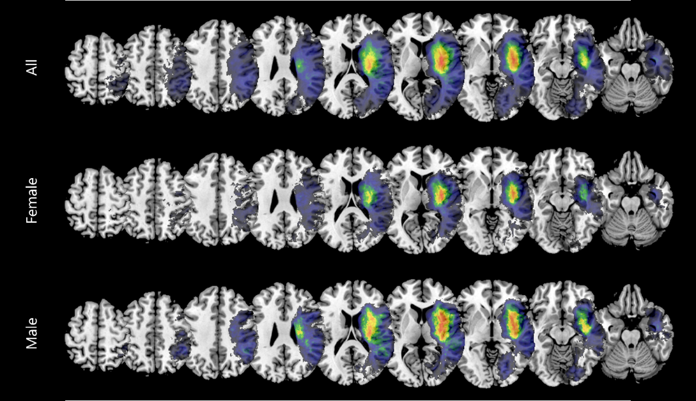

Overlaps of all normalised acute lesions included in the analyses are shown for all patients (N = 206), female and male patients (N = 103, respectively). Aggregated lesions were overlaid on an axial view of the ch2bet-template in MRIcron (Rorden & Brett, 2000). The voxels’ colours indicate the frequency of the lesion overlap and were scaled to the respective sample sizes. Only voxels damaged in at least 5 patients are depicted and were used for subsequent analyses. Colours were scaled from 5 to the maximum value of the respective patient sample. The number given above each slice refers to the z-coordinate in MNI space.

Figure 2a depicts the voxels that were damaged more frequently in one sex than the other in Subtraction Plots. The voxels that most notably were damaged more often in women were mostly clustered in the Thalamus and the Putamen and Ventral Caudate of the Basal Ganglia (BG). The voxels that were damaged more frequently in men were spread out more across the brain. Notable clusters include the Inferior Frontal Gyrus (IFG), Orbital Gyrus (OrG), Superior Temporal Gyrus (STG) and posterior STG and Medioventral Occipital Cortex (MVOcC).

When contrasting only female and male patients diagnosed with visuospatial neglect (see Figure 2b), the patterns look very similar to the ones found for the whole patient sample. The most prominent cluster of voxels damaged more frequently in women than in men is located again in the BG, but another notable cluster emerged surrounding the Middle Frontal Gyrus (MFG). Male neglect patients had more damaged voxels in the Dorsal Caudate region of the Basal Ganglia, the Inferior Parietal Lobule (IPL) and STG. 🡪 supplementary?

**Figure 2:** Subtraction Plots

Female > Male:



Male > Female:



Neglect Female > Neglect Male:



Neglect Male > Neglect Female:



Subtraction plots of the normalised acute lesions for the (A) female and male patient sample and (B) female and male neglect patient sample, respectively. Subtraction maps were overlaid on an axial view of the ch2bet-template in MRIcron (Rorden & Brett, 2000). The voxels’ colours indicate the percentage of relative frequency difference between the patient groups. Only voxels damaged in at least 5 patients are depicted and were used for subsequent analyses. The number given above each slice refers to the z-coordinate in MNI space.

Figure 3 depicts the voxels whose damage status was significantly correlated with worse behavioural scores, as assessed via VLBM analyses using mass-univariate general linear models. Across all patients, 4232 voxels survived the correction and reached significance. The majority of those voxels is located around the IPL, STG, the posterior Superior Temporal Sulcus (pSTS) and their associated WM fibre tracts. In the female patient subgroup, a total of 323 mostly grey matter voxels clustered around the pSTS and STG reached significance. In the male subsample, damage to a population of 273 voxels that are mainly located in WM tracts surrounding the IPL and between the STG and Middle Temporal Gyrus (MTG) were significantly associated with pathological behaviour.

**Figure 3:** Statistical voxel-wise lesion-behaviour mapping (VLBM) results

All:



Female:



Male:



Results of the VLBM analyses using mass-univariate GLMs to identify voxels that are significantly correlated with pathological scores in the behavioural tasks. Voxels that survived FWE correction based on permutation tests at p < 0.05 are overlaid in red on an axial view of the ch2bet-template in MRIcron (Rorden & Brett, 2000). The number given above each slice refers to the z-coordinate in MNI space.

### Whole-brain Disconnectivity

Figure 4 illustrates the percentage of disconnected fibres for every WM voxel as an overlay plot across the patient sample. Disconnections are more pronounced in the right hemisphere, spanning the entire anterior-posterior-axis from the middle frontal gyrus via the orbital gyrus, basal ganglia and thalamus to the inferior temporal gyrus and finally the occipital pole. This corresponds to pronounced disconnections affecting the (inferior) occipitofrontal fasciculus and inferior longitudinal fasciculus. Further, especially the posterior segments of the corpus callosum are damaged. Disconnections also affected parts of the corticospinal tract, the uncinate fasciculus, as well as the anterior segment of the arcuate fasciculus. (BN-246 for cortical areas; Natbrainlab Atlas for WM tracts)

**Figure 4:** Disconnection Overlay Plots



Overlaps of the whole-brain disconnections included in the analyses are shown for all patients (N = 206), female and male patients (N = 103, respectively). Aggregated disconnection maps were overlaid on an axial view of the ch2bet-template in MRIcron (Rorden & Brett, 2000). The voxels’ colours indicate the frequency of the disconnection overlap and were scaled to the respective sample sizes. Only voxels disconnected in at least 5 patients are depicted and were used for subsequent analyses. Colours were scaled from 5 to the maximum value of the respective patient sample. The number given above each slice refers to the z-coordinate in MNI space.

Comparing the disconnection overlays between the male and female subgroups, as well as subtraction plots (see Figure 5) revealed the following differences: Women exhibited a higher percentage of disconnections in the splenium of the corpus callosum, throughout the entire cingulum, as well as the thalamus compared to men. Generally, the disconnections that occurred more frequently in women tend to follow the (inferior) occipitofrontal fasciculus, inferior longitudinal fasciculus and corticospinal tract. In contrast to this, men generally experience more disconnections throughout the entire corpus callosum, but especially in the genu and rostrum, and in more cortical grey matter areas.

**Figure 5:** Subtraction Plots of Whole-brain disconnectivity

Female:



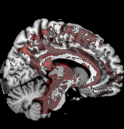 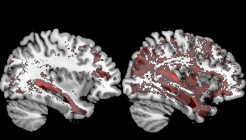 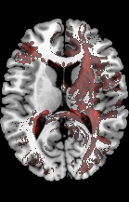

Male:



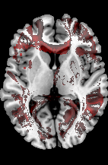 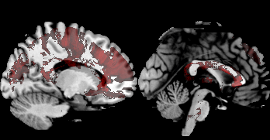 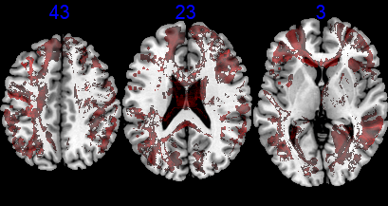

The VLBM analyses we applied to identify any voxels whose disconnection status is significantly correlated with pathological behaviour yielded no significant results. No voxels survived the threshold – neither across all patients, nor for the female or male subsamples.

### Region-to-Region Disconnectivity

Using GLMs to map pathological behaviour to ROI-to-ROI disconnectivity, we identified a large number of significant disconnections at p = 0.05 (see Figure 6 & Table 2): Across all patients, 893 disconnections reached significance. 205 significant disconnections were identified in the female patient group and 611 disconnections were significantly correlated with pathological behaviour in the male subsample.

**Figure 6:** Significant Parcel-wise disconnections

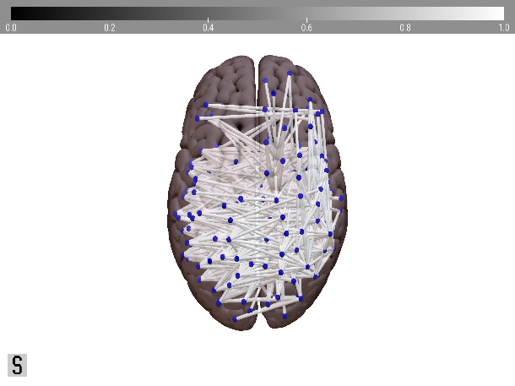 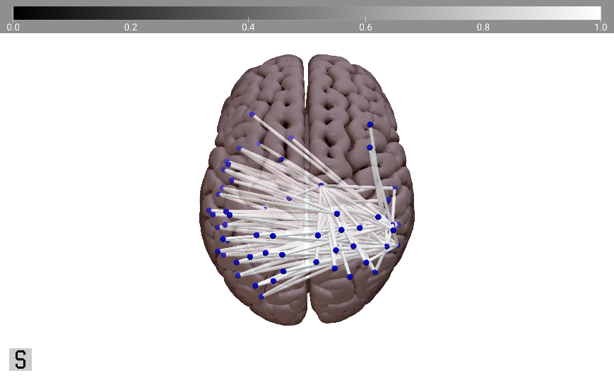 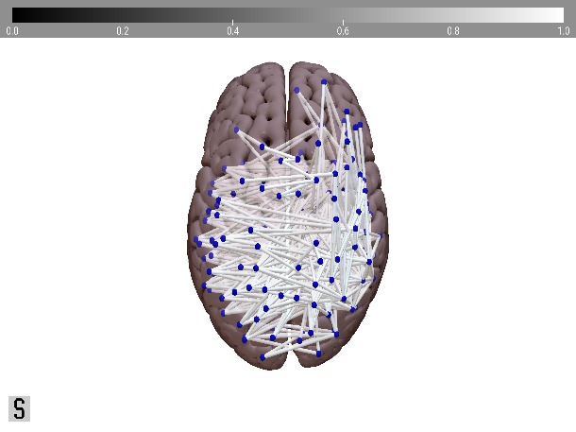

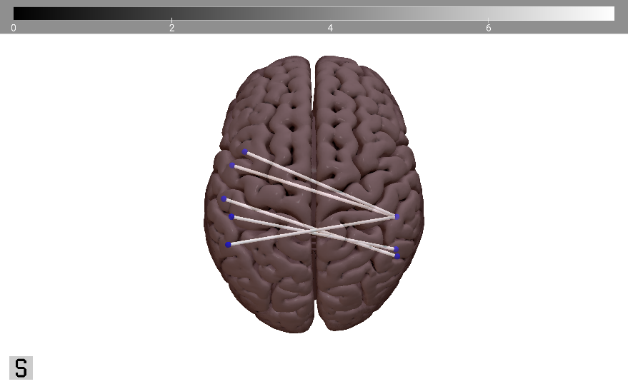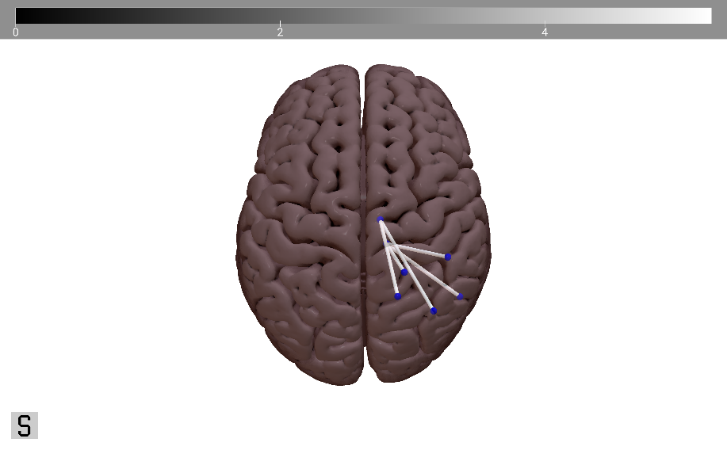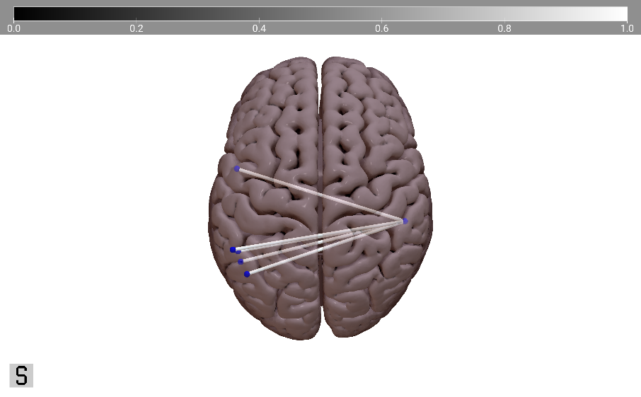

Significant parcel-wise disconnections, overlaid on a superior view of the MNI152-template in SurfIce ([NITRC, 2015](https://www.nitrc.org/projects/surfice/)). The blue nodes correspond to (sub-)cortical parcels as defined by the BN-246 atlas (Fan et al., 2016) and the white edges to the disconnected fibre streamlines between those parcels as defined by the HCP-842 atlas (Yeh et al., 2018). (A) shows the significant disconnections at p = 0.05 for the entire patient sample (N = 893), and the female (N = 205) and male (N = 611) subsamples, respectively. (B) presents the 5 most significant disconnections (i.e., the ones with the highest T-values) for the patient (sub-)samples.

Generally, disconnections involving the IPL were the most common (see Table 2 for an overview, and Supplementary Table 3 for details): 34.8% of all disconnections across the whole patient sample had one of their endpoints in the IPL. IPL-related disconnections were also the most common disconnection in the male subsample, attributing for 30.9% of their disconnections. In the female subsample, however, the majority of disconnections (48.3%) was associated with the ITG. Here, IPL-related disconnections were the third most common (27.8%), after disconnections involving the pSTS (36.1%). (more?)

**Table 2:** Overview Significant Parcel-wise Disconnections at p = 0.05

|  |  |  |  |  |
| --- | --- | --- | --- | --- |
|  | Total  (N = 206) | Female  (N = 103) | Male  (N = 103) | p-value |
| Significant Disconnections  *(N, Ratio Inter- : Intra-hemispheric)* | 893, 607 : 286 | 205, 145 : 60 | 611, 428 : 183 | 0.853b |
| Node with highest number of sign. disconnections (Anatomical Label, % of all disconnections) | right A39rv (PGa) of IPL (5.38%) | right cpSTS  (18.54%) | right A39rv (PGa) of IPL (6.87%) |  |
| ROI with highest number of sign. disconnections (Anatomical Label, % of all disconnections) | IPL (34.8%) | ITG (48.3%) | IPL (30.9%) |  |

Selected summary statistics resulting from the parcel-wise disconnection analysis at p = 0.05. Results are either given as number of significant disconnections, number of interhemispheric disconnections : number of intrahemispheric disconnections or as anatomical label based on BN-246 atlas (Fan et al., 2016) (contributing to percentage of disconnections). More details can be found in Appendix B, Supplementary Table 3.

In women, the five disconnections that were most significantly associated with pathological behavioural scores were all right intrahemispheric disconnections involving the Thalamus, specifically the occipital and caudal temporal segments of the Thalamus. In contrast to this, the five most significant disconnections in men were all interhemispheric disconnections involving the right caudoventral ITG.

In women, the disconnection that most significantly was associated with pathological behavioural scores was between the ventrolateral ITG and the occipital Thalamus of the right hemisphere. [more]

**Table 3:** Most significant Parcel-wise Disconnections

|  |  |  |  |
| --- | --- | --- | --- |
|  | Node A | Node B | T-value |
| T O T A L | left MTG  (rostral area 21) | right ITG (caudoventral area 20) | 7.5929 |
| left MTG (anterior STS) | right ITG (ventrolateral area 37) | 7.3804 |
| left STG (lateral area 38) | right ITG (caudoventral area 20) | 7.3375 |
| left IPL (rostroventral area / PFop) | right ITG (extreme lateroventral area 20) | 7.3282 |
| left IPL (caudal area 40/PFm) | right ITG (caudoventral area 20) | 7.3147 |
| F E M A L E | right ITG  (ventrolateral area 37) | right Thalamus (occipital thalamus) | 5.2566 |
| right SPL (postcentral area 7) | right Thalamus (occipital thalamus) | 5.0743 |
| right SPL (rostral area 7) | right Thalamus (caudal temporal thalamus) | 5.0445 |
| right IPL (rostrodorsal area 39 / Hip3) | right Thalamus (caudal temporal thalamus) | 4.8381 |
| right IPL (rostrodorsal area 40 / PFt) | right Thalamus (occipital thalamus) | 4.8380 |
| M A L E | left ITG (extreme lateroventral area 37) | right ITG (caudoventral area 20) | 6.6931 |
| left MTG  (rostral area 21) | right ITG (caudoventral area 20) | 6.6168 |
| left IPL (rostroventral area 39 / PGa) | right ITG (caudoventral area 20) | 6.3379 |
| left IPL (caudal area 40 / PFm) | right ITG (caudoventral area 20) | 6.3214 |
| left pSTS (caudoposterior STS) | right ITG (caudoventral area 20) | 6.3154 |

Parcel-wise disconnections with the highest T-values following the region-to-region analysis for the patient (sub-) samples. Anatomical labels are based on the BN-246 atlas (Fan et al., 2016). Abbreviations can be found in Appendix A. Intrahemispheric disconnections are highlighted in light grey. T-values were obtained from the GLM analysis, employing maximum statistic permutation at 50,000 permutations.

### Lesion-induced Increase in Shortest Structural Path Lengths (SSPLs)

We detected no significant differences in mean indirect SSPL increase between women and men. However, the increase in the maximum SSPL values yielded a significant difference between the sexes (see Table 4): The male patient subsample had an average maximum SSPL value of 3.204 (SD = 1.240) and the female subsample’s average was 3.544 (SD = 1.027).

**Table 4:** Increase in different SSPL measures across the patient sample

|  |  |  |  |  |
| --- | --- | --- | --- | --- |
|  | Total (N = 206) | Female  (N = 103) | Male  (N = 103) | p-value |
| Mean Indirect SSPL | 0.253 (0.307) [0 – 1.584] | 0.237 (0.278) [0 – 1.429] | 0.270 (0.335) [0 – 1.584] | 0.448a |
| Max Indirect SSPL | 3.374 (1.148) [0 – 6] | 3.544 (1.027) [1 – 5] | 3.204 (1.240) [0 – 6] | **0.033a** |

Results are given as mean (standard deviation) [range]. For the calculation of p-values, it was first confirmed that the samples had equal variances and then an equal variances t-test (‘a’, for continuous variables) was calculated.   
p-values < 0.05 are considered significant and highlighted in bold.

We detected no significant correlation between increase of indirect SSPLs and pathological behaviour in any of the patient (sub-)samples using the Spearman correlation approach outlined in Section 3.4. However, in a Supplementary analysis using a Bayesian correlation approach described in Appendix C, we found some significant indirect SSPL increases (see Appendix C, Supplementary Analysis 2).

### Prediction of Patient Status

Table 5 provides an overview of the nu-SVC prediction accuracies that were based on voxel-wise disconnection maps and lesion maps, respectively. Prediction accuracy was highest for the classification of Neglect vs Control patients at 66% for the disconnection-based and 53.4% for the lesion-based classification. Model performances were below chance level for the classification of sex: Prediction accuracy was slightly higher for the model trained on lesion maps (48.5%) than for the one trained on disconnection maps (46.6%). For the four-class classification of sex-specific patient groups, the performance of the model trained on lesion maps was slightly below chance level (24.3%), whereas the disconnection-based model achieved a prediction accuracy of 32.5%.

**Table 5:** Prediction accuracy for lesion-based and disconnection-based instance matrices

|  |  |  |
| --- | --- | --- |
| Predicted Variable | Average Prediction Accuracy | |
| **Lesion Maps** | **Disconnection Maps** |
| Female vs Male | 48.54 % | 46.60% |
| Neglect vs Control | 53.40% | 66.02% |
| FNeg vs FCon vs MNeg vs MCon | 24.27% | 32.52% |

nu-SVC model performances as assessed by average prediction accuracy for the models trained on voxel-wise disconnection maps and lesion maps, respectively. Three versions of patient status were predicted: Sex (i.e., Female vs Male), diagnosis (i.e., Neglect vs Control) and sex-specific patient group (i.e., female neglect, female control, male neglect, male control).

## Discussion

### Clinical and Demographic Data

* Women older at stroke onset than men
* Women more often neglect than men
* Women slightly smaller lesions
* Men more infarcts, women more haemorrhages
* Differences in arterial territories

### Lesion Analysis / VLBM

* Lesion overlap smaller in women + more focussed on BG; men: more spread, BG + insula
* Subtraction (= more power) shows women more lesions in thalamus, putamen, BG; men more spread out, e.g. in IFG, OrG, STG & MVOcC
* VLBM revealed small significant clusters of neurons in typical neglect regions

### Whole-brain disconnectivity

* Women more intrahemispheric disconnections in thalamus, cingulum, IOF, ILF & CST; interhemispheric disconnections mainly in splenium of CC
* Men more interhemispheric disconnections throughout CC (esp. genu & rostrum); more cortical grey matter areas
* No VLBM results 🡪 maybe not suited for context-dependent analyses such as disconnectivity

### ROI disconnectivity

* Very large number of significant disconnections; roughly 70% interhemispheric disconnections at p=0.05 (68% all, 71% fem, 70% male)
* IPL involved in majority of disconnections for all & men 🡪 role in neglect?
* In women, more disconnections in STS/ITG
* Most significant disconnections in women involve thalamus, in men ITG

### SSPLs

### Prediction

### Limitations

* Would require sex-specific atlases (parcellation, tractography + normalization templates) that don’t exist yet

### Outlook

## Conclusion

## References

Allen, J. S., Damasio, H., Grabowski, T. J., Bruss, J., & Zhang, W. (2003). Sexual dimorphism and asymmetries in the gray–white composition of the human cerebrum. NeuroImage, 18(4), 880–894. <https://doi.org/10.1016/s1053-8119(03)00034-x>

Becker, E., & Karnath, H. O. (2010). Neuroimaging of eye position reveals spatial neglect. Brain, 133(3), 909–914. <https://doi.org/10.1093/brain/awq011>

Bengtsson, H. (2018). R.matlab: Read and Write MAT Files and Call MATLAB from Within R.   
R package version 3.6.2. <https://CRAN.R-project.org/package=R.matlab>

Beschin, N., Cocchini, G., della Sala, S., & Logie, R. H. (1997). What the Eyes Perceive, The Brain Ignores: A Case of Pure Unilateral Representational Neglect. Cortex, 33(1), 3–26. <https://doi.org/10.1016/s0010-9452(97)80002-0>

Bisiach, E., & Luzzatti, C. (1978). Unilateral Neglect of Representational Space. Cortex, 14(1), 129–133. <https://doi.org/10.1016/s0010-9452(78)80016-1>

Boespflug, E. L., Storrs, J. M., Allendorfer, J. B., Lamy, M., Eliassen, J. C., & Page, S. (2011). Mean diffusivity as a potential diffusion tensor biomarker of motor rehabilitation after electrical stimulation incorporating task specific exercise in stroke: a pilot study. Brain Imaging and Behavior, 8(3), 359–369. <https://doi.org/10.1007/s11682-011-9144-1>

Bonkhoff, A. K., Schirmer, M. D., Bretzner, M., Hong, S., Regenhardt, R. W., Brudfors, M., Donahue, K. L., Nardin, M. J., Dalca, A. V., Giese, A. K., Etherton, M. R., Hancock, B. L., Mocking, S. J. T., McIntosh, E. C., Attia, J., Benavente, O. R., Bevan, S., Cole, J. W., Donatti, A., . . . Rost, N. S. (2021). Outcome after acute ischemic stroke is linked to sex-specific lesion patterns. Nature Communications, 12(1). <https://doi.org/10.1038/s41467-021-23492-3>

Bowen, A., McKenna, K., & Tallis, R. C. (1999). Reasons for Variability in the Reported Rate of Occurrence of Unilateral Spatial Neglect After Stroke. Stroke, 30(6), 1196–1202. <https://doi.org/10.1161/01.str.30.6.1196>

Broverman, I. K., Vogel, S. R., Broverman, D. M., Clarkson, F. E., & Rosenkrantz, P. S. (1972). Sex-Role Stereotypes: A Current Appraisal. Journal of Social Issues, 28(2), 59–78. <https://doi.org/10.1111/j.1540-4560.1972.tb00018.x>

Bushnell, C. D., Chaturvedi, S., Gage, K. R., Herson, P. S., Hurn, P. D., Jiménez, M. C., Kittner, S. J., Madsen, T. E., McCullough, L. D., McDermott, M., Reeves, M. J. & Rundek, T. (2018). Sex differences in stroke: Challenges and opportunities. Journal of Cerebral Blood Flow & Metabolism, 38(12), 2179–2191. <https://doi.org/10.1177/0271678x18793324>

Buxbaum, L., Ferraro, M., Veramonti, T., Farne, A., Whyte, J., Ladavas, E., Frassinetti, F., & Coslett, H. (2004). Hemispatial neglect: Subtypes, neuroanatomy, and disability. Neurology, 62(5), 749–756. <https://doi.org/10.1212/01.wnl.0000113730.73031.f4>

Catani, M. & Thiebaut De Schotten, M. (2008). A diffusion tensor imaging tractography atlas for virtual in vivo dissections. Cortex, 44(8), 1105–1132. <https://doi.org/10.1016/j.cortex.2008.05.004>

Chang, C.-C., & Lin, C.-J. (2011). LIBSVM: A library for support vector machines. ACM Transactions on Intelligent Systems and Technology, 2(3), 27:1-27:27. <https://doi.org/10.1145/1961189.1961199>

Clas, P., Groeschel, S. & Wilke, M. (2012). A Semi-Automatic Algorithm for Determining the Demyelination Load in Metachromatic Leukodystrophy. Academic Radiology, 19(1), 26–34. <https://doi.org/10.1016/j.acra.2011.09.008>

Corbetta, M. (2014). Hemispatial Neglect: Clinic, Pathogenesis, and Treatment. Seminars in Neurology, 34(05), 514–523. <https://doi.org/10.1055/s-0034-1396005>

de Haan, B., Clas, P., Juenger, H., Wilke, M., & Karnath, H. O. (2015). Fast semi-automated lesion demarcation in stroke. NeuroImage: Clinical, 9, 69–74. <https://doi.org/10.1016/j.nicl.2015.06.013>

de Haan, B., & Karnath, H. O. (2018). A hitchhiker’s guide to lesion-behaviour mapping. Neuropsychologia, 115, 5–16. <https://doi.org/10.1016/j.neuropsychologia.2017.10.021>

Evans, A., Collins, D., Mills, S., Brown, E., Kelly, R. & Peters, T. (1993). 3D statistical neuroanatomical models from 305 MRI volumes. 1993 IEEE Conference Record Nuclear Science Symposium and Medical Imaging Conference. <https://doi.org/10.1109/nssmic.1993.373602>

Fan, L., Li, H., Zhuo, J., Zhang, Y., Wang, J., Chen, L., Yang, Z., Chu, C., Xie, S., Laird, A. R., Fox, P. T., Eickhoff, S. B., Yu, C. & Jiang, T. (2016). The Human Brainnetome Atlas: A New Brain Atlas Based on Connectional Architecture. Cerebral Cortex, 26(8), 3508–3526. <https://doi.org/10.1093/cercor/bhw157>

Fee, E. (1979). Nineteenth-Century Craniology: The Study of the Female Skull. Bulletin of the History of Medicine, 53(3), 415–433. <http://www.jstor.org/stable/44450930>

Feigin, V. L., Forouzanfar, M. H., Krishnamurthi, R., Mensah, G. A., Connor, M., Bennett, D. A., Moran, A. E., Sacco, R. L., Anderson, L., Truelsen, T., O’Donnell, M., Venketasubramanian, N., Barker-Collo, S., Lawes, C. M. M., Wang, W., Shinohara, Y., Witt, E., Ezzati, M., Naghavi, M., & Murray, C. (2014). Global and regional burden of stroke during 1990–2010: findings from the Global Burden of Disease Study 2010. The Lancet, 383(9913), 245–255. <https://doi.org/10.1016/s0140-6736(13)61953-4>

Gauthier, L., Dehaut, F., & Joanette, Y. (1989). The Bells Test: A Quantitative and Qualitative Test for Visual Neglect. *International Journal of Clinical Neuropsychology*, *XI*(2), 49–54.

GBD 2019 Stroke Collaborators. (2021). Global, regional, and national burden of stroke and its risk factors, 1990–2019: a systematic analysis for the Global Burden of Disease Study 2019. The Lancet Neurology, 20(10), 795–820. <https://doi.org/10.1016/S1474-4422(21)00252-0>

Gibson, C. L. (2013). Cerebral Ischemic Stroke: is Gender Important? Journal of Cerebral Blood Flow & Metabolism, 33(9), 1355–1361. <https://doi.org/10.1038/jcbfm.2013.102>

Gibson, C. L., Coomber, B., & Rathbone, J. (2009). Is Progesterone a Candidate Neuroprotective Factor for Treatment following Ischemic Stroke? The Neuroscientist, 15(4), 324–332. <https://doi.org/10.1177/1073858409333069>

Goldstein, J. M., Seidman, L. M., Horton, N. J., Makris, N., Kennedy, D. N., Caviness, Jr., V. S., Faraone, S. V., & Tsuang, M. T. (2001). Normal Sexual Dimorphism of the Adult Human Brain Assessed by In Vivo Magnetic Resonance Imaging. Cerebral Cortex, 11(6), 490–497. <https://doi.org/10.1093/cercor/11.6.490>

Grabowska, A. (2016). Sex on the brain: Are gender-dependent structural and functional differences associated with behavior? Journal of Neuroscience Research, 95(1–2), 200–212. <https://doi.org/10.1002/jnr.23953>

Gray, J. (2009). Men Are from Mars, Women Are from Venus: The Classic Guide to Understanding the Opposite Sex (digital edition). HarperCollins e-books. <https://books.google.de/books?id=gOa0hfqT-M8C>

Griffis, J. C., Metcalf, N. V., Corbetta, M. & Shulman, G. L. (2020). Damage to the shortest structural paths between brain regions is associated with disruptions of resting-state functional connectivity after stroke. NeuroImage, 210, 116589. <https://doi.org/10.1016/j.neuroimage.2020.116589>

Griffis, J. C., Metcalf, N. V., Corbetta, M. & Shulman, G. L. (2021). Lesion Quantification Toolkit: A MATLAB software tool for estimating grey matter damage and white matter disconnections in patients with focal brain lesions. NeuroImage: Clinical, 30, 102639. <https://doi.org/10.1016/j.nicl.2021.102639>

Henderson, V. W., & Lobo, R. A. (2012). Hormone therapy and the risk of stroke: perspectives 10 years after the Women's Health Initiative trials. Climacteric, 15(3), 229–234. <https://doi.org/10.3109/13697137.2012.656254>

Herbet, G. & Duffau, H. (2022). Contribution of the medial eye field network to the voluntary deployment of visuospatial attention. Nature Communications, 13(1). <https://doi.org/10.1038/s41467-022-28030-3>

Hirnstein, M., Hugdahl, K., & Hausmann, M. (2019). Cognitive sex differences and hemispheric asymmetry: A critical review of 40 years of research. Laterality: Asymmetries of Body, Brain and Cognition, 24(2), 204–252. <https://doi.org/10.1080/1357650x.2018.1497044>

Hollingworth, L. S. (1918). Comparison of the sexes in mental traits. Psychological Bulletin, 15(12), 427–432. <https://doi.org/10.1037/h0075023>

Hyde, J. S. (2005). The gender similarities hypothesis. American Psychologist, 60(6), 581–592. <https://doi.org/10.1037/0003-066x.60.6.581>

Hyde, J. S. (2014). Gender Similarities and Differences. Annual Review of Psychology, 65(1), 373–398. <https://doi.org/10.1146/annurev-psych-010213-115057>

Ingalhalikar, M., Smith, A., Parker, D., Satterthwaite, T. D., Elliott, M. A., Ruparel, K., Hakonarson, H., Gur, R. E., Gur, R. C. & Verma, R. (2013). Sex differences in the structural connectome of the human brain. Proceedings of the National Academy of Sciences, 111(2), 823–828. <https://doi.org/10.1073/pnas.1316909110>

Jackson, D., Kirkbride, J., Croudace, T., Morgan, C., Boydell, J., Errazuriz, A., Murray, R. M. & Jones, P. B. (2013). Meta‐analytic approaches to determine gender differences in the age‐incidence characteristics of schizophrenia and related psychoses. International Journal of Methods in Psychiatric Research, 22(1), 36–45. <https://doi.org/10.1002/mpr.1376>

Jensen, A., Castro, A. W., Ferretti, M. T., Martinkova, J., Vasilevskaya, A., Santuccione Chadha, A. & Tartaglia, A. C. (2022). Sex and gender differences in the neurological and neuropsychiatric symptoms of long COVID: A narrative review. The Italian Journal of Gender-Specific Medicine, 8(1), 18–28. <https://doi.org/10.1723/3769.37563>

Kanaan, R. A., Allin, M., Picchioni, M., Barker, G. J., Daly, E., Shergill, S. S., Woolley, J., & McGuire, P. K. (2012). Gender Differences in White Matter Microstructure. PLoS ONE, 7(6), e38272. <https://doi.org/10.1371/journal.pone.0038272>

Karnath, H. O. (2015). Spatial attention systems in spatial neglect. Neuropsychologia, 75, 61–73. <https://doi.org/10.1016/j.neuropsychologia.2015.05.019>

Karnath, H. O., & Dieterich, M. (2006). Spatial neglect—a vestibular disorder? Brain, 129(2), 293–305. <https://doi.org/10.1093/brain/awh698>

Karnath, H. O., & Niemeier, M. (2002). Task-dependent differences in the exploratory behaviour of patients with spatial neglect. Neuropsychologia, 40(9), 1577–1585. <https://doi.org/10.1016/s0028-3932(02)00020-9>

Karnath, H. O., & Rorden, C. (2012). The anatomy of spatial neglect. Neuropsychologia, 50(6), 1010–1017. <https://doi.org/10.1016/j.neuropsychologia.2011.06.027>

Karnath, H. O., Sperber, C., Wiesen, D., & de Haan, B. (2019). Lesion-Behavior Mapping in Cognitive Neuroscience: A Practical Guide to Univariate and Multivariate Approaches. Spatial Learning and Attention Guidance, 209–238. <https://doi.org/10.1007/7657_2019_18>

Kasties, V., Karnath, H. & Sperber, C. (2021). Strategies for feature extraction from structural brain imaging in lesion‐deficit modelling. Human Brain Mapping, 42(16), 5409–5422. <https://doi.org/10.1002/hbm.25629>

Katan, M., & Luft, A. (2018). Global Burden of Stroke. Seminars in Neurology, 38(02), 208–211. <https://doi.org/10.1055/s-0038-1649503>

Kovalev, V. A., Kruggel, F. & von Cramon, D. (2003). Gender and age effects in structural brain asymmetry as measured by MRI texture analysis. NeuroImage, 19(3), 895–905. <https://doi.org/10.1016/s1053-8119(03)00140-x>

Li, K., & Malhotra, P. A. (2015). Spatial neglect. Practical Neurology, 15(5), 333–339. <https://doi.org/10.1136/practneurol-2015-001115>

Li, H., Pin, S., Zeng, Z., Wang, M. M., Andreasson, K. A., & McCullough, L. D. (2005). Sex differences in cell death. Annals of Neurology, 58(2), 317–321. <https://doi.org/10.1002/ana.20538>

Liu, M., Kelley, M. H., Herson, P. S., & Hurn, P. D. (2010). Neuroprotection of Sex Steroids. Minerva Endocrinologica, 35(2), 127–143.

Liu, M., Oyarzabal, E. A., Yang, R., Murphy, S. J., & Hurn, P. D. (2008). A novel method for assessing sex-specific and genotype-specific response to injury in astrocyte culture. Journal of Neuroscience Methods, 171(2), 214–217. <https://doi.org/10.1016/j.jneumeth.2008.03.002>

Liu, R., & Yang, S.-H. (2013). Window of opportunity: Estrogen as a treatment for ischemic stroke. Brain Research, 1514, 83–90. <https://doi.org/10.1016/j.brainres.2013.01.023>

Manwani, B., Bentivegna, K., Benashski, S. E., Venna, V. R., Xu, Y., Arnold, A. P., & McCullough, L. D. (2014). Sex Differences in Ischemic Stroke Sensitivity Are Influenced by Gonadal Hormones, Not by Sex Chromosome Complement. Journal of Cerebral Blood Flow & Metabolism, 35(2), 221–229. <https://doi.org/10.1038/jcbfm.2014.186>

Nichols, T. E. & Holmes, A. P. (2002). Nonparametric permutation tests for functional neuroimaging: A primer with examples. Human Brain Mapping, 15(1), 1–25. <https://doi.org/10.1002/hbm.1058>

Nuzzo, R. L. (2017). An Introduction to Bayesian Data Analysis for Correlations. PM&R, 9(12), 1278–1282. <https://doi.org/10.1016/j.pmrj.2017.11.003>

R Core Team (2018). R: A language and environment for statistical computing. R Foundation for Statistical Computing, Vienna, Austria. URL <https://www.R-project.org/>

Röhrig, L., Sperber, C., Bonilha, L., Rorden, C. & Karnath, H. O. (2022). Right hemispheric white matter hyperintensities improve the prediction of spatial neglect severity in acute stroke. medRxiv. <https://doi.org/10.1101/2022.04.08.22273547>

Rorden, C., Bonilha, L., Fridriksson, J., Bender, B., & Karnath, H. O. (2012). Age-specific CT and MRI templates for spatial normalization. NeuroImage, 61(4), 957–965. <https://doi.org/10.1016/j.neuroimage.2012.03.020>

Rorden, C., & Brett, M. (2000). Stereotaxic Display of Brain Lesions. Behavioural Neurology, 12(4), 191–200. <https://doi.org/10.1155/2000/421719>

Rorden, C., & Karnath, H. O. (2010). A simple measure of neglect severity. *Neuropsychologia*, *48*(9), 2758–2763. <https://doi.org/10.1016/j.neuropsychologia.2010.04.018>

Schölkopf, B., Platt, J. C., Shawe-Taylor, J., Smola, A. J. & Williamson, R. C. (2001). Estimating the Support of a High-Dimensional Distribution. Neural Computation, 13(7), 1443–1471. <https://doi.org/10.1162/089976601750264965>

Schölkopf, B., Smola, A. J., Williamson, R. C. & Bartlett, P. L. (2000). New Support Vector Algorithms. Neural Computation, 12(5), 1207–1245. <https://doi.org/10.1162/089976600300015565>

Sherman, J. A. (1967). Problem of sex differences in space perception and aspects of intellectual functioning. Psychological Review, 74(4), 290–299. <https://doi.org/10.1037/h0024723>

Shields, S. (1975). Functionalism, Darwinism, and the psychology of women. American Psychologist, 30(7), 739–754. <https://doi.org/10.1037/h0076948>

Snyder, H. M., Asthana, S., Bain, L., Brinton, R., Craft, S., Dubal, D. B., Espeland, M. A., Gatz, M., Mielke, M. M., Raber, J., Rapp, P. R., Yaffe, K. & Carrillo, M. C. (2016). Sex biology contributions to vulnerability to Alzheimer’s disease: A think tank convened by the Women’s Alzheimer’s Research Initiative. Alzheimer’s & Dementia, 12(11), 1186–1196. <https://doi.org/10.1016/j.jalz.2016.08.004>

Sperber, C. & Karnath, H. O. (2017). Impact of correction factors in human brain lesion-behavior inference. Human Brain Mapping, 38(3), 1692–1701. <https://doi.org/10.1002/hbm.23490>

Stone, S. P., Halligan, P. W., & Greenwood, R. J. (1993). The Incidence of Neglect Phenomena and Related Disorders in Patients with an Acute Right or Left Hemisphere Stroke. Age and Ageing, 22(1), 46–52. <https://doi.org/10.1093/ageing/22.1.46>

Suzuki, S., Brown, C. M., & Wise, P. M. (2009). Neuroprotective effects of estrogens following ischemic stroke. Frontiers in Neuroendocrinology, 30(2), 201–211. <https://doi.org/10.1016/j.yfrne.2009.04.007>

Ten Brink, A. F., Verwer, J. H., Biesbroek, J. M., Visser-Meily, J. M. A., & Nijboer, T. C. W. (2016). Differences between left- and right-sided neglect revisited: A large cohort study across multiple domains. Journal of Clinical and Experimental Neuropsychology, 39(7), 707–723. <https://doi.org/10.1080/13803395.2016.1262333>

Voyer, D., Voyer, S. D. & Saint-Aubin, J. (2016). Sex differences in visual-spatial working memory: A meta-analysis. Psychonomic Bulletin & Review, 24(2), 307–334. <https://doi.org/10.3758/s13423-016-1085-7>

Weintraub, S., & Mesulam, M. M. (1985). Mental state assessment of the young and elderly adults in behavioral neurology. In M. M. Mesulam (Ed.), Principles of Behavioral Neurology (pp. 71–123). Philadelphia, PA: FA Davis

Wickham, H., François, R., Henry, L. & Müller, K. (2019). dplyr: A Grammar of Data Manipulation. R package version 0.8.0.1. <https://CRAN.R-project.org/package=dplyr>

Wickham, H. & Henry, L. (2019). tidyr: Easily Tidy Data with 'spread()' and 'gather()' Functions. R package version 0.8.3. <https://CRAN.R-project.org/package=tidyr>

Wise, P. M., Dubal, D. B., Wilson, M. E., Rau, S. W., Böttner, M., & Rosewell, K. L. (2001). Estradiol is a protective factor in the adult and aging brain: understanding of mechanisms derived from in vivo and in vitro studies. Brain Research Reviews, 37(1-3), 313–319. <https://doi.org/10.1016/s0165-0173(01)00136-9>

Wittig, M. A. (1976). Sex differences in intellectual functioning: How much of a difference do genes make? Sex Roles, 2(1), 63–74. <https://doi.org/10.1007/bf00289299>

Woolley, H. T. (1914). The psychology of sex. Psychological Bulletin, 11(10), 353–379. <https://doi.org/10.1037/h0070064>

Yeh, F. C., Panesar, S., Fernandes, D., Meola, A., Yoshino, M., Fernandez-Miranda, J. C., Vettel, J. M. & Verstynen, T. (2018). Population-averaged atlas of the macroscale human structural connectome and its network topology. NeuroImage, 178, 57–68. <https://doi.org/10.1016/j.neuroimage.2018.05.027>

Zasler, N. D., & Kaplan, P. E. (2017). Fractional Anisotropy. Encyclopedia of Clinical Neuropsychology, 1. <https://doi.org/10.1007/978-3-319-56782-2_32-2>

Zell, E., Krizan, Z., & Teeter, S. R. (2015). Evaluating gender similarities and differences using metasynthesis. American Psychologist, 70(1), 10–20. <https://doi.org/10.1037/a0038208>

Zhang, Y., Kimberg, D. Y., Coslett, H. B., Schwartz, M. F. & Wang, Z. (2014). Multivariate lesion-symptom mapping using support vector regression. Human Brain Mapping, 35(12), 5861–5876. <https://doi.org/10.1002/hbm.22590>

## Acknowledgements

Throughout the duration of my thesis, I have received a great deal of support and academic guidance.

First and foremost, I would like to express my deepest gratitude to my primary supervisors Lisa Röhrig and Stefan Smaczny.

## Data Usage Statement

To the largest part, custom MATLAB and R scripts were used for data analysis that were written by Tamara Keßler. In some instances, however, openly available scripts published by other researchers were used:

Röhrig, L. (2022). Dataset for: Right hemispheric white matter hyperintensities improve the prediction of spatial neglect severity in acute stroke. Mendeley Data, V1, DOI: [10.17632/c8n42jz525.1](https://data.mendeley.com/datasets/c8n42jz525/1)

Smaczny, S. (2022a). Left angular gyrus disconnection impairs multiplication fact retrieval, descriptive data and scripts. Mendeley Data, V2, DOI: [10.17632/yjkr647mzb.2](https://data.mendeley.com/datasets/yjkr647mzb/2)

Smaczny, S. (2022b). Bayesian Disconnection R.R. Github, URL: [https://github.com/ssmaczny/Stefan-Smaczny-Neuropsychology/blob/master/Bayesian%20  
Disconnection%20R.R](https://github.com/ssmaczny/Stefan-Smaczny-Neuropsychology/blob/master/Bayesian%20Disconnection%20R.R)

Sperber, C. (2022). Scripts and tutorials for indirect structural disconnection-symptom mapping by Sperber, Griffis & Kasties. Mendeley Data, V2, DOI: [10.17632/hdzptzz8r5.2](https://data.mendeley.com/datasets/hdzptzz8r5)

## Appendix

### Appendix A: List of Abbreviations

|  |  |
| --- | --- |
| ACA | Anterior Cerebral Artery |
| CoC | Centre of Cancellation |
| CT | Computed Tomography |
| CV | Cross Validation |
| DTI | Diffusion Tensor Imaging |
| DWI | Diffusion-weighted Imaging |
| FA | Functional Anisotropy |
| GLM | Generalised Linear Model |
| HCP | Human Connectome Project |
| IOF | Inferior Occipitofrontal Fasciculus |
| IPL | Inferior Parietal Lobule |
| ITG | Inferior Temporal Gyrus |
| LQT | Lesion Quantification Toolkit |
| MCA | Medial Cerebral Artery |
| MD | Mean Diffusivity |
| MNI | Montreal Neurological Institute |
| MRI | Magnetic Resonance Imaging |
| MTG | Middle Temporal Gyrus |
| nu-SVC | nu-Support Vector Classification |
| PCA | Posterior Cerebral Artery |
| pSTS | Posterior Superior Temporal Sulcus |
| ROI | Region Of Interest |
| SLF | Superior Longitudinal Fasciculus |
| SOF | Superior Occipitofrontal Fascicle |
| SPL | Superior Parietal Lobule |
| SSPL | Shortest Structural Path Length |
| STG | Superior Temporal Gyrus |
| STS | Superior Temporal Sulcus |
| T2FLAIR | T2-weighted Fluid Attenuated Inversion Recovery |
| TPJ | Temporo-Parietal Junction |
| VLBM | Voxel-based Lesion-Behaviour Mapping |
| vlPFC | Ventrolateral Prefrontal Cortex |
| WM | White Matter |

### Appendix B: Supplementary Tables and Figures

**Supplementary Table 1a:** Clinical and Demographic Data of Neglect Patients

|  |  |  |  |  |
| --- | --- | --- | --- | --- |
|  | Total  (N = 73) | Female  (N = 40) | Male  (N = 33) | p-value |
| Age *(years)* | 65.1 (13.9) [29-93] | 67.5 (14.3) [34-93] | 62.3 (12.8) [29-81] | 0.114a |
| Days between Stroke & Imaging | 3.4 (3.5) [0-14] | 3.4 (3.6) [0-14] | 3.4 (3.4) [0-14] | 0.971a |
| Aetiology *(Infarct, Haemorrhage, Both)* | 55, 15, 3 | 28, 10, 2 | 27, 5, 1 | 0.507b |
| Lesion volume *(cm3)* | 63.8 (44.8) [0.37-312.6] | 58.2 (62.3) [0.09-312.6] | 70.0 (51.6) [0.37-194.7] | 0.416a |
| Arterial Territory of Infarct *(ACA, MCA, PCA)* |  |  |  |  |
| Days between Stroke & Assessment | 4.0 (2.9) [0-14] | 4.0 (2.9) [0-14] | 3.8 (2.8) [0-13] | 0.709a |
| Letter CoC | 0.42 (0.31) [-0.02-0.99] | 0.39 (0.31) [-0.02-0.99] | 0.44 (0.30) [-0.001-0.96] | 0.487a |
| Bells CoC | 0.39 (0.28) [-0.1-0.92] | 0.33 (0.28) [-0.1-0.92] | 0.46 (0.27) [0-0.91] | 0.058a |
| Copying Errors | 2.93 (2.31) [0-7] | 2.67 (2.21) [0-7] | 3.34 (2.35) [0-7] | 0.132a |
| Mean z-Score | 0.97 (1.05) [-0.6-3.04] | 0.80 (1.03) [-0.45-3.04] | 1.19 (1.03) [-0.6-2.93] | 0.116a |
| Visual field defects *(N)* | 17 | 9 | 8 | 0.940b |

**Supplementary Table 1b:** Clinical and Demographic Data of Control Patients

|  |  |  |  |  |
| --- | --- | --- | --- | --- |
|  | Total  (N = 133) | Female  (N = 63) | Male  (N = 70) | p-value |
| Age *(years)* | 61.2 (13.9) [26-88] | 62.4 (15.8) [26-88] | 60.1 (11.7) [36-83] | 0.328a |
| Days between Stroke & Imaging | 2.7 (2.9) [0-11] | 2.4 (2.7) [0-11] | 2.9 (3.0) [0-11] |  |
| Aetiology *(Infarct, Haemorrhage, Both)* | 114, 19, 0 | 51, 12, 0 | 63, 7, 0 |  |
| Lesion volume *(cm3)* | 20.8 (24.7) [0.09-138.1] | 19.6 (19.2) [0.16-70.5] | 21.7 (28.7) [0.09-138.1] | 0.595a |
| Arterial Territory of Infarct *(ACA, MCA, PCA)* |  |  |  |  |
| Days between Stroke & Assessment | 2.6 (2.6) [0-12] | 3.9 (2.3) [1-9] | 3.3 (3.0) [0-12] |  |
| Letter CoC | 0.02 (0.07) [-0.06-0.78] | 0.02 (0.02) [-0.02-0.08] | 0.02 (0.10) [-0.06-0.80] |  |
| Bells CoC | 0.03 (0.09) [-0.11-0.83] | 0.03 (0.05) [-0.04-0.26] | 0.03 (0.11) [-0.11-0.83] |  |
| Copying Errors | 0.22 (0.58) [0-4] | 0.27 (0.65) [0-4] | 0.16 (0.51) [0-3] |  |
| Mean z-Score | -0.5 (0.25) [-0.75-1.99] | -0.5 (0.14) [-0.64-0.09] | -0.51 (0.32) [-0.75-1.99] |  |
| Visual field defects *(N)* | 15 | 7 | 8 |  |

Results are given as either number of patients or mean (standard deviation) [range]. The lesion volume was computed for the normalised lesion in MNI space. For the calculation of p-values, it was first confirmed that the samples had equal variances and then either an equal variances t-test (‘a’, for continuous variables) or a Chi2 test (‘b’, for categorical variables) was calculated. p-values < 0.05 are considered significant and highlighted in bold.  
Abbreviations: *N* – Number of patients, *ACA* – Anterior Cerebral Artery, *MCA* – Medial Cerebral Artery, *PCA* – Posterior Cerebral Artery, *CoC* – Centre of Cancellation (Rorden & Karnath, 2010)

**Supplementary Table 2:** Used Scan Modalities for all patients

|  |  |  |  |
| --- | --- | --- | --- |
|  | Total  (N = 206) | Female  (N = 103) | Male  (N = 103) |
| CT | 98 | 57 | 41 |
| T2FLAIR | 54 | 24 | 30 |
| T2FLAIR + T1 | 11 | 4 | 7 |
| DWI | 18 | 8 | 10 |
| DWI + T1 | 19 | 8 | 11 |
| DWI + T2FLAIR | 6 | 2 | 4 |

Results are given as number of patients. MR scans were preferred over CT scans, if both modalities were available. In patients with multiple MR modalities, we preferentially used DWI if the images were acquired less than 48 hours after stroke and T2FLAIR for images that were acquired later. Abbreviations: See Appendix A.

**Supplementary Table 3**: Number of significant disconnections per Region at p = 0.05

|  |  |  |  |  |  |  |  |  |  |  |  |  |
| --- | --- | --- | --- | --- | --- | --- | --- | --- | --- | --- | --- | --- |
|  | Total  (N = 893) | | Female  (N = 205) | | | | Male (N = 611) | | | | p-value | |
| Amygdala (Amyg) | 12 | (1.34%) | 0 | (0.00%) | | 7 | | (1.14%) | |  | |
| Basal Ganglia (BG) | 60 | (6.72%) | 2 | (0.96%) | | 37 | | (6.06%) | |  | |
| Fusiform Gyrus (FuG) | 24 | (2.69%) | 1 | (0.49%) | | 18 | | (2.94%) | |  | |
| Hippocampus (Hipp) | 27 | (3.02%) | 3 | (1.46%) | | 13 | | (2.13%) | |  | |
| Inferior Frontal Gyrus (IFG) | 12 | (1.34%) | 0 | (0.00%) | | 4 | | (0.65%) | |  | |
| Insula (Ins) | 8 | (0.89%) | 0 | (0.00%) | | 9 | | (1.47%) | |  | |
| Inferior Parietal Lobule (IPL) | 311 | (34.83%) | 57 | (27.80%) | | 189 | | (30.93%) | |  | |
| Inferior Temporal Gyrus (ITG) | 286 | (32.03%) | 99 | (48.29%) | | 261 | | (42.72%) | |  | |
| Lateral Occipital Cortex (LOcC) | 93 | (10.41%) | 9 | (4.39%) | | 80 | | (13.09%) | |  | |
| Middle Frontal Gyrus (MFG) | 31 | (3.47%) | 3 | (1.46%) | | 23 | | (3.76%) | |  | |
| Middle Temporal Gyrus (MTG) | 174 | (19.48%) | 45 | (21.95%) | | 160 | | (26.19%) | |  | |
| Medioventral Occipital Cortex (MVOcC) | 15 | (1.68%) | 0 | (0.00%) | | 12 | | (1.96%) | |  | |
| Orbital Gyrus (Org) | 15 | (1.68%) | 2 | (0.96%) | | 19 | | (3.11%) | |  | |
| Paracentral Lobule (PCL) | 4 | (0.45%) | 0 | (0.00%) | | 0 | | (0.00%) | |  | |
| Precuneus (Pcun) | 33 | (3.70%) | 6 | (2.93%) | | 19 | | (3.11%) | |  | |
| Parahippocampal Gyrus (PhG) | 3 | (0.34%) | 0 | | (0.00%) | | 5 | | (0.82%) | |  | |
| Postcentral Gyrus (PoG) | 59 | (6.61%) | 3 | | (1.46%) | | 25 | | (4.89%) | |  | |
| Precentral Gyrus (PrG) | 33 | (3.70%) | 2 | | (0.96%) | | 24 | | (3.93%) | |  | |
| Posterior Superior Parietal Sulcus (pSTS) | 107 | (11.98%) | 74 | | (36.10%) | | 33 | | (5.40%) | |  | |
| Superior Frontal Gyrus (SFG) | 17 | (1.90%) | 0 | | (0.00%) | | 14 | | (2.29%) | |  | |
| Superior Parietal Lobule (SPL) | 151 | (16.91%) | 35 | | (17.07%) | | 91 | | (14.89%) | |  | |
| Superior Temporal Gyrus (STG) | 156 | (17.47%) | 18 | | (8.78%) | | 118 | | (19.31%) | |  | |
| Thalamus (Tha) | 155 | (17.36%) | 51 | | (24.88%) | | 61 | | (9.98%) | |  | |

Results are given as number of significant disconnections associated with this region (percentage relative to total number of disconnections). Regions are based on the BN-246 (Fan et al., 2016) atlas. It is important to note that these percentages add up to 200% – this is because there are always 2 nodes/regions involved in a disconnection. Thus, there are twice as many disconnected nodes as there are disconnections.

**Supplementary Figure 1a:** Lesion Overlay Plots for Neglect Patients

All Neglect:

Ein Bild, das Text, Keramikwaren, Zahnrad enthält.

Female Neglect:

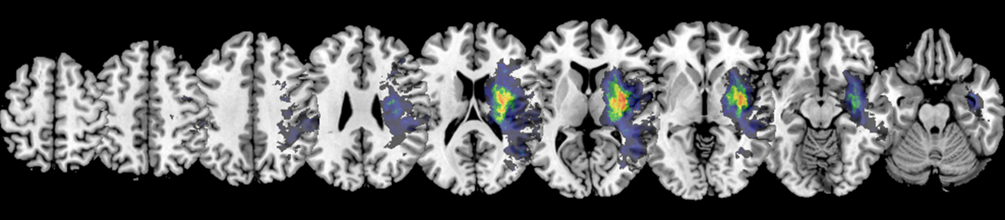

Male Neglect:

Ein Bild, das Text, Primat, Säugetier enthält.

**Supplementary Figure 1b:** Lesion Overlay Plots for Control Patients

All Control:

Ein Bild, das Text, Rad, Zahnrad enthält.

Female Control:

Ein Bild, das Text, Zahnrad enthält.

Male Control:

Ein Bild, das Text enthält.

**Supplementary Figure 2:** Significant Parcel-wise Disconnections resulting from Bayesian Correlation

All:

Ein Bild, das Text, orange enthält.

Female:

Ein Bild, das orange, Molluske, dunkel enthält.

Male:

Ein Bild, das Text, Molluske, orange enthält.

**Supplementary Figure 3:** Significant increases in indirect SSPLs resulting from Bayesian Correlation

All:

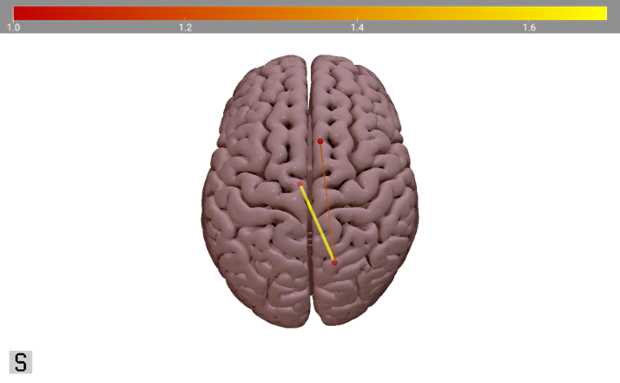

Female:



Male:

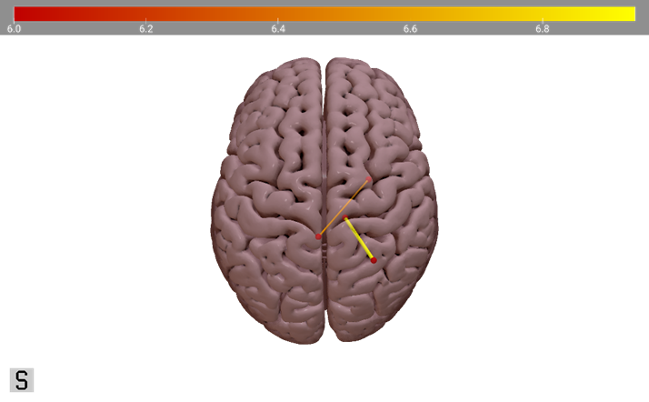

### Appendix C: Supplementary Analyses

**Supplementary Analysis 1:** Bayesian Correlation for Region-to-Region Disconnectivity

In order to assess which direct disconnections between two grey matter regions are significantly associated with increased neglect severity, we used custom R (R Core Team, 2018) scripts to calculate Bayesian correlations (for an overview see Nuzzo, 2017). For this, we used the R.matlab (Bengtsson, 2018), tidyr (Wickham & Henry, 2019) and dplyr (Wickham et al., 2019) packages.

First, we loaded the symmetric 246-by-246 disconnectivity matrices into R and removed the diagonal and elements below it. We also removed any ROI-to-ROI disconnections that are either (physiologically) non-existent in the patient sample or are present in less than 20% of the patient sample (All = 40; F = 20; M = 20) (cf. Herbet & Duffau, 2022; Sperber & Karnath, 2017). After removing those data, we computed a Bayesian correlation for the remaining ROI-to-ROI connections, using the disconnectivity score as the independent variable and the behavioural score as the dependent variable. Again, we repeated this analysis for the whole patient sample, the female patients, and the male patients, separately.

We found the same patterns of significant parcel-wise disconnections as described in Section 4.4., providing extreme evidence in favour of our hypothesis as assessed via Bayes Factors (see Supplementary Figure 2; cf. Andraszewicz et al., 2014; Jarosz & Wiley, 2014).

**Supplementary Analysis 2:** Bayesian Correlation for SSPL Increase

To investigate if the increase in SSPLs between two grey matter regions are significantly associated with pathological behavioural scores, we used custom R (R Core Team, 2018) scripts employing the R.matlab (Bengtsson, 2018), tidyr (Wickham & Henry, 2019) and dplyr (Wickham et al., 2019) packages.

As described in Section 3.3. and Supplementary Analysis 1, we removed the redundant elements from the matrix, as well as all disconnections that are present in less than 20% of the patient sample. Then, we calculated a Bayesian correlation between the behavioural data and the SSPL values across the patient (sub-)samples. We repeated this analysis three times – once for the whole patient sample, and then for the male and female subsamples separately.

Using this Bayesian approach, we detected some significant indirect SSPL increases where the frequentist analysis did not find any as described in Section 4.5. Those significant SSPL increases are shown in Supplementary Figure 3.

Indirect SSPL Increases with the highest Bayes Factors

|  |  |  |  |
| --- | --- | --- | --- |
| All | Left Thalamus (medial pre-frontal thalamus) | Right Pcun  (dorsomedial parietooccipital sulcus (PEr)) | 5.43 |
| Female | Right STG (area 41/42) | Right CG (caudal area 23) | 1.19 |
| Male | Right SPL (intraparietal area 7 (hIP3) | Right Thalamus (occipital Thalamus) | 1034 |